Gwaith Cartref

Arywr Antur Cymraeg!  (Collect them from the classroom)   | Play on Mathletics.   |   Make a healthy meal or snack
  Exercise |   Create a piece of Art | Write about your favourite animals  
Times Tables   | Gardening  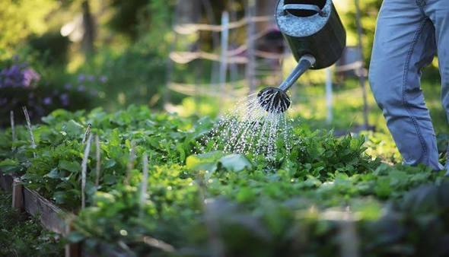 | An Activity of your choice  
Write a book review   |   Go on a litter pick | Create a sculpture  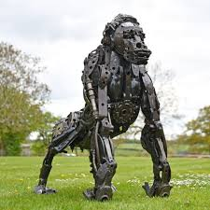
Here are 12 activities, designed by you, to be completed as homework during the Autumn Term. Choose one per week. Once you have completed an activity upload to Google Classroom or hand in to Mr Dobbs.

