Gwaith Cartref

Arywr Antur Cymraeg!  (Collect them from the classroom)   | Play on Sum Dog.   | Write about your favourite character  
Researching a new Country  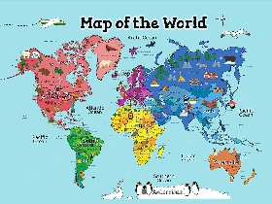 | Make up a story.   | Help someone in your family  
Times Table Sports  (Catching, throwing, kicking balls etc)   | Create a Treasure Hunt around your garden or house  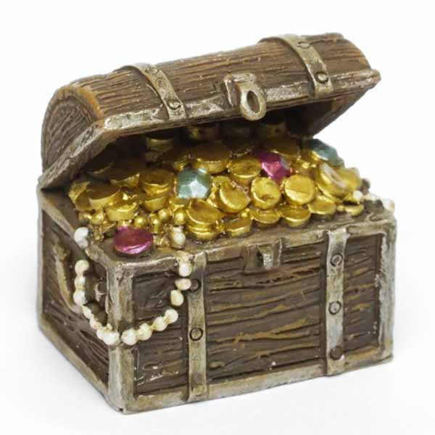 | An Activity of your choice
Here are 9 activities, designed by you, to be completed as homework during the Autumn Term. Choose one per week. Once you have completed an activity upload to Google Classroom.

