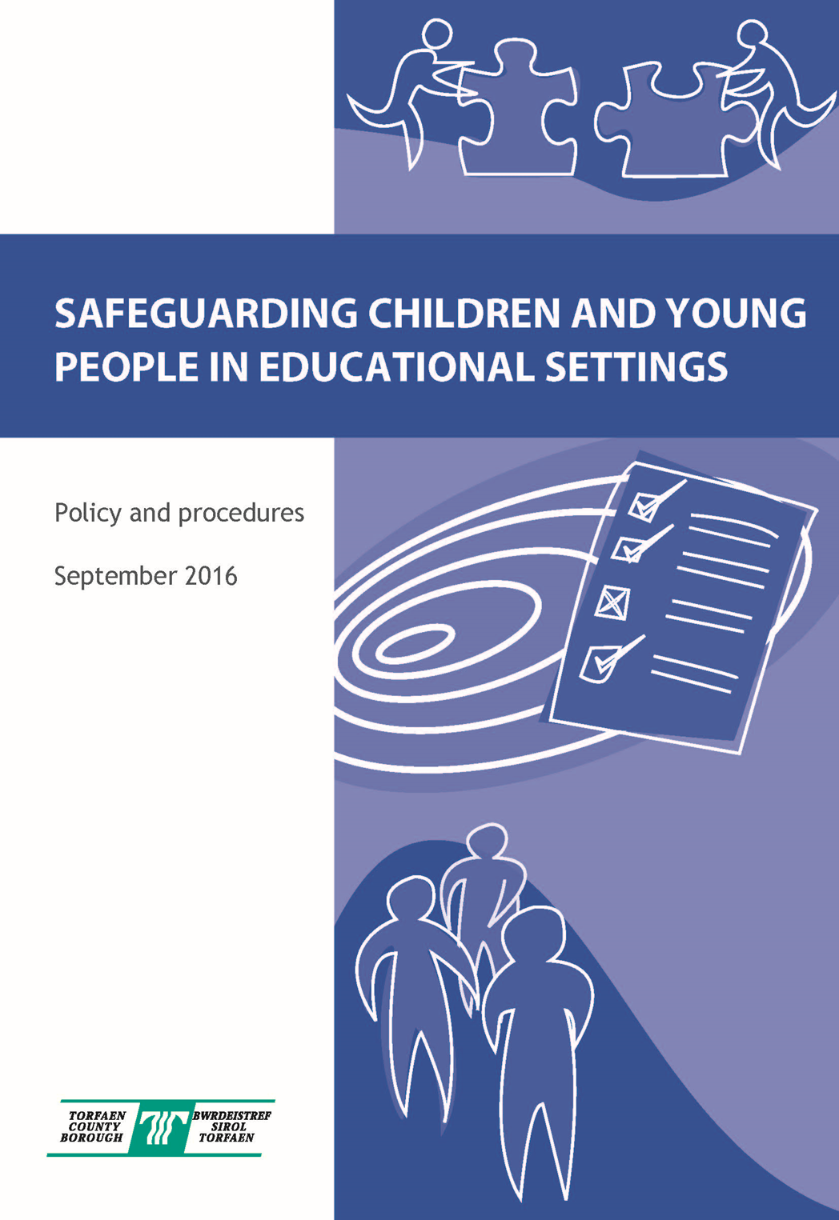
Safeguarding Procedures & School Model Policy

September 2025

Contents

Policy Statement 4

Roles and Responsibilities – Quick Reference Guide

  - Governing Bodies 5
    - When parents involve Governors 6
    - Role of the Chair of Governors 6
    - The Role of the Safeguarding Children Governor (SCG) 7
    - Role of all Governors 7

  - Schools 8
    - Role of the Designated Safeguarding Person (DSP)

  - Local Authority 10

The Referral Process 11
- Making a Referral 12

Model Policy for Schools 14

Introduction 16

School Commitment 16

1. Safer Recruitment and Selection 17
2. Safe Practice 17
3. Safeguarding Information for Pupils 18
4. Partnership with Parents 18
5. Partnership with Others 19
6. School Training and Staff Induction 19
7. Support, Advice and Guidance for Staff 19
8. Children Missing from Education 20
9. Confidentiality 20
10. Pupil Information 20
11. Roles and Responsibilities: 21
- Governing Body 21
- Headteacher 22
- DSP 22
- All Staff and Volunteers 23

Identifying Children and Young People who may be
suffering significant Harm 24

Taking Action to ensure that Children are Safe at 26
School and at Home
Supporting the Pupil at Risk 28
Violence Against Women, Domestic Abuse and Sexual Violence 29
(VAWDASV)
Operation Encompass 29
Safeguarding pupils who are vulnerable to 29
Extremism – the Prevent Duty
Female Genital Mutilation (FGM) Mandatory 30
Reporting Duty
Harmful Sexual Behaviour 30
Children with Additional Learning Needs 30
Staff Must Immediately Report 30
Responding to Disclosure 31
Action by DSP 31
Action following a Child Protection referral 32
Recording and Monitoring 32
Supporting the Child and Partnership with Parents 33

Allegations regarding person(s) working in 33
or on behalf of school (including volunteers)

Safeguarding Responsibilities in Specific Circumstances 35

References 36

Appendices

- Legislative Framework 37
- Categories of Abuse 41
- Section 175 Safeguarding Self Evaluation Tool User Guide & Link 42
- Report to strategy meeting pro forma 46
- Safeguarding Incident Log 49
- Duty to Report Form 50
- PREVENT Duty Risk Assessment Tool 53
- Transfer of Child Protection Records Within Educational Establishment 54

POLICY STATEMENT

Torfaen County Borough Council is committed to improve the quality of life for people in
Torfaen and to ensure there are effective working practices which protect children and
young people from harm in every Council setting.

Safeguarding Children, Young People and Adults at Risk sets out the Council’s Policy and Guidelines for the safeguarding of children, young people and adults at risk.

The Safeguarding Policy and Guidelines:

- Explains how the Council undertakes its legal commitments for safeguarding of children, young people and adults at risk.
- Provides assurance to members of the public, service users, elected members, employees and people working on behalf of the Council that there are clear arrangements in place to safeguard and protect children, young people and adults at risk
- Provides Council staff and elected members with clear guidelines for when a child, young person or adult at risk may be at risk of harm.

Staff within the Education Service accept and recognise our responsibilities to develop awareness of the issues which cause children, young people and adults at risk harm and to continuously develop and review our practices.

We will safeguard children, young people and adults at risk by:

- Making safeguarding our key priority

- Adopting guidelines which provide clear procedures for all staff – these are outlined in detail in this document.

- Sharing information about child protection and safeguarding with children, parents and carers, staff and volunteers.

- Promptly sharing information about concerns with agencies which need to know and involving parents and children appropriately.

- Following the procedures for safe recruitment and selection of staff.

- Updating our safeguarding training at regular intervals.

- Providing effective management for staff and volunteers through supervision, support and training.

- We are also committed to constantly monitor and review our policy and practices and share good practice at regular intervals.

This document has been written for all education staff but particularly for those in schools, including volunteers and governors. All education settings must revisit their Safeguarding policy annually and should ensure all staff, including staff from elsewhere visiting school, are made familiar with its expectations. Additionally, where pupils go on trips or visit external education providers or work placements, schools should find this policy and guidance helpful in ensuring good safeguarding practices are maintained.

ROLES & RESPONSIBILITIES

GOVERNING BODIES

Governing Bodies are accountable for ensuring effective policies and procedures are in place to safeguard and promote the welfare of children, monitor their compliance with them and ensure that their establishment has:

Policy and procedures in place consistent with Gwent Safeguarding Board guidelines and the Local Authority Safeguarding Children and Young People Policy. The Governing Body is expected to review these annually and ensure that parents are aware a policy is in place and available to see on request. A model policy for schools to adopt is included in this document. Governors must also ensure their school has a member of the senior management team who is designated with lead responsibility for child protection referred to as the Designated Safeguarding Person (DSP) that they are properly trained and have time to carry out their duties. The governing body should satisfy themselves that should the nominated member of staff not be in school for any reason, there are robust systems in place to ensure any safeguarding issue can be dealt with appropriately and efficiently.

- Governors should receive information on safeguarding activity within their establishment without breaching confidentiality. This information should be used as part of the ongoing and annual review of the school’s policy and procedures and the governing body must remedy without delay any deficiencies or weaknesses regarding any child protection arrangements brought to its attention.

- We continue to recommend and in accordance with Clywch recommendations and WG Guidance 272/2021 Keeping Learners Safe that each Governing Body has a lead Governor to ensure that child protection is receiving proper consideration – the Safeguarding Children Governor (SCG)

- Governors also need to operate safe recruitment and retention procedures in accordance with Local Authority (LA) guidance and oversee safe recruitment of staff. This includes ensuring that all members of staff, including unsupervised volunteers, have an enhanced Disclosure and Barring Service (DBS) check at the point of employment with the school. All DBS’s should be renewed every three years, with the exception of supply teachers (where portability applies), and a register of DBS’s should be maintained and regularly monitored.

- In accordance with WG Guidance 272/2021 Keeping Learners Safe governors should ensure their school has an explicit written recruitment and selection policy statement that complies with LA guidance, e.g.:

This school is committed to safeguarding and promoting the welfare of children and young people and expects all staff and volunteers to share this commitment.

- Governors should ensure the Head teacher and senior management team have robust processes in place to ensure the well-being of pupils educated off-site, in work placements and with other providers. Where students are considered to be vulnerable (e.g. because the student has additional learning needs) the governing body should also ensure that any additional steps have been taken to protect these vulnerable pupils – this is particularly important for secondary school governors.

- Governors must ensure, where services or activities are provided on the school premises by another body, that the body concerned has appropriate policies and procedures in place regarding safeguarding and that there are arrangements in place to liaise with the school on these matters. A register of all activities should also be retained.

- The Chair of Governors (COG) must take the lead if an allegation is made against the Head teacher, seeking immediate advice from the Director of Education. In these circumstances Education Human Resources will also offer prompt advice to the chair of governors.

- Governors should ensure that the Designated Safeguarding Person (DSP) for child protection, their deputy, the Safeguarding Children Governors (SCG) and the Chair of Governors (COG) undertake training to support them in their roles in accordance with Gwent Safeguarding Board and LA requirements and that it is refreshed to keep their knowledge and skills up to date.

- The Governing Body must ensure that any data required by the LA for monitoring purposes is made available.

Governors will ensure their Head teacher and all other staff and volunteers who work with children undertake training to equip them with the knowledge and skills that are necessary to carry out their responsibilities for child protection effectively, which is kept up to date by refresher training as required by the LA/Gwent Safeguarding Board.

Governors are responsible for the safeguarding of all pupils on the school roll (see Education Act 2002 section 175 detailed in Appendix 1).

When Parents Involve Governors in Child Protection Issues

- Explain that governors do not have an operational role in child protection (unless you are the Chair of Governors – see below)
- Refer any concerns to the Head teacher
- Where criticisms are made of any aspect of a case, (e.g. its progress or staff involved) then refer any concerns to the Head teacher

Role of Chair of Governors

Requires liaison (taking care with confidentiality) with the Head teacher/DSP regarding allegations of child abuse against a member of staff or volunteer.

Where there is an allegation of child abuse (see Appendix 2) against the Head teacher, the Chair of Governors has responsibility for the oversight of procedures relating to liaison with the Lead Safeguarding Officer for the Education Service, Multi-Agency Support & Safeguarding Hub (MASSH) and Police.

This may include possible involvement in multi-agency strategy discussions (though no direct investigatory role, rather providing information and ensuring good communication between all parties)

The Role of the Safeguarding Children Governor (SCG)

The SCG plays a key role in ensuring the governing body fulfils its responsibilities in respect of safeguarding children. These responsibilities include:

- ensuring the school has an effective safeguarding children policy in place which is reviewed annually and follows local procedures and includes consideration of how its responsibilities have been discharged
- contributing to the completion of the Section 175 Safeguarding Self Evaluation Tool (see appendix 3)
- ensuring the school adopts safe recruitment and retention procedures for its staff and volunteers
- ensuring procedures are in place for dealing with allegations of abuse made against staff and volunteers
- ensuring a designated senior member of staff is appointed for dealing with safeguarding children issues
- ensures the above duties are discharged.

As the governor responsible for safeguarding children, you will take responsibility for all child protection matters and play an essential role in ensuring children in education are kept safe from harm. Your job is to ensure the safeguarding agenda is embedded in the ethos of your school.

Safeguarding Children - The Role of all Governors

The safeguarding agenda includes a wide range of issues from monitoring pastoral care and anti-bullying strategies to ensuring children are kept safe from abuse and neglect. All members of governing bodies should undertake relevant safeguarding training and child protection training.

Here are some ways in which you can help your school fulfil its duties:

- keep up to date with national and local guidance
- ensure policies and procedures are in place and reviewed regularly
- ensure safeguarding children matters are kept on the agenda at school and governor meetings
- ensure all school policies are child focused and consider any potential safeguarding children issues
- ensure that all staff and volunteers who work with children undertake training to equip them with the knowledge and skills necessary to carry out their responsibilities for child protection effectively and that this training is kept up to date

All staff should receive basic safeguarding children information at induction and undertake formal training every 3 years – there should however be an opportunity to refresh safeguarding training annually along with regular discussions at staff meetings. Those in school with specific safeguarding children responsibility e.g. the DSP, Deputy DSP, SCG and COG should attend more comprehensive training to support them in their roles which should be refreshed at least every two years. All governors should undertake basic safeguarding children training and as a minimum should complete modules 1,2,3 & 5 of the Keeping Learners Safe Modules.

School’s Role

For more detailed information on all aspects of schools’ safeguarding procedures please refer to the model safeguarding policy in the next section of the document (page 14).

Role of the Designated Safeguarding Person (DSP)

Each school/learning provider must have a DSP with lead responsibility for managing safeguarding & child protection issues and cases. This person must be a member of the school’s/learning provider’s leadership or management team. The post holder must be appropriately trained in accordance with LA and Gwent Safeguarding Board requirements and able to provide advice and support to other staff. The responsibility for this training rests with the school/setting although the Local Authority provides safeguarding training for DSP’s and Designated Governors. Various safeguarding training courses are also available via the Gwent Safeguarding Board at www.gwentsafeguarding.org.uk

The DSP should seek to ensure their organisation creates an ethos which helps children feel secure and able to talk freely, in the knowledge that they will be listened to and their concerns taken seriously. A Deputy DSP should also be appointed to provide support and cover the role of the DSP when that person is unavailable.

The Head teacher should ensure that the DSP

- Is given sufficient time and resources to carry out the role effectively, which should be explicitly defined in the post holder’s job description
- Has access to required levels of training and support to undertake the role
- Has time to attend and provide reports and advice to case conferences and other interagency meetings as required (see Appendix 4 for Report to strategy meeting pro forma)

The DSP should:

- Take responsibility for and provide information and advice on safeguarding & child protection practice, policy and professional development within the school or service and working with other agencies as necessary

- Act as a point of contact and a source of support, advice and expertise within the school/setting when deciding whether it is necessary to make a referral by liaising with the relevant agencies as required

- Ensure the school’s/setting’s safeguarding policy is updated and reviewed annually

- Ensure the Section 175 Safeguarding Self Evaluation Tool is completed annually (see appendix 3)

- Ensure new and temporary members of staff and volunteers are aware of procedures and how to obtain advice. Where other groups use the school site the DSP should ensure other site users are aware of the school’s or settings’ high expectations on safeguarding and ask to see the group’s safeguarding policy

- Raise awareness of the policy and procedures with parents and carers

- Liaise with the SCG so they can report on safeguarding issues to the governing body

- Ensure that the school or setting’s Safeguarding Policy and Procedures are adhered to and inform Social Care of relevant concerns about individual children.

- Liaise with Social Care and the Police as appropriate.

- Be aware of the Gwent Safeguarding Board and be familiar with procedures.

- Use My Concern (or an appropriate alternative system if the school is not using My Concern) to maintain detailed, accurate and secure records of children where there are safeguarding concerns. These records are confidential and should be kept separately from pupil records. They should include a chronology of concerns, referrals, meetings, phone calls and emails.

- Ensure that an individual case record/child protection log is maintained of the action taken by the school/setting, the liaison with other agencies and that the outcome is recorded. See Appendix 5 – Safeguarding Incident Log for details of the information that should be included

- Ensure that appropriate information is available at the time of referral and that the referral is confirmed in writing, under confidential cover in accordance with the referral process.

- Identify training needs within the school/learning service and ensure that all staff, governors and volunteers are appropriately trained and kept up to date with new legislation etc. All DSPs should ensure their own training is updated every two years.

- Ensure a record of all safeguarding training is maintained and monitored.

- Ensure the appropriate member(s) of staff attend child protection strategy meetings and that the school provides written reports. The school should always provide a written report in addition to attending the strategy meeting or review – the report should be given to the child protection strategy meeting chairperson whether it is asked for or not.

- When children leave the school/setting the DSP should ensure their child protection file is copied to the new establishment as soon as possible. It should be transferred separately from the main pupil file in accordance with the LA School’s Retention Policy.

- Support the Head teacher and Chair of Governors in ensuring the school has robust safe recruitment and allegation procedures.

ROLE OF THE LOCAL AUTHORITY

The Local Authority (LA) has responsibilities with regards to safeguarding at three levels and will ensure that Gwent Safeguarding Board guidelines are adhered to.

Strategic Responsibilities

At this level the LA will ensure:

- All partners allocate resources to support the work of the Gwent Safeguarding Board
- Senior Officers, including Education, represent the LA on the Gwent Safeguarding Board and that the LA makes an effective contribution to planning co-ordinated services to meet the needs of children
- Work with other agencies to put in place and support effective partnership working
- Resources are allocated to enable the LA and maintained schools to discharge their responsibilities for safeguarding children satisfactorily
- Effective liaison with the appropriate Diocesan Authorities in respect of arrangements for aided schools in the area
- Monitor the compliance of maintained schools/settings with WG Guidance – Keeping Learners Safe
- Resolve inter-agency problems as soon as they are identified
- Play a full part in child practice reviews in accordance with requirements

Support Responsibilities

At this level the LA will ensure

- That induction training for all new staff in the service and staff who work with children in schools, includes training on safeguarding that will enable them to fulfil their responsibilities effectively in respect of child protection. The LA will also ensure refresher training is completed.
- That governors receive appropriate training on their safeguarding responsibilities and in handling allegations of abuse against school staff
- Ensure that further training in inter-agency working and refresher training to safeguard children is available either from the Gwent Safeguarding Board or in line with standards set by the Gwent Safeguarding Board.
- A record of all designated safeguarding persons (DSP’s) and designated governors for child protection within schools is maintained as well as a record of the training undertaken
- Model policies are provided for schools on all aspects of child protection, including recruitment and procedures for dealing with allegations of abuse against staff and volunteers consistent with WG Guidance
- Allegations of abuse are overseen and that there is liaison with the police and the MASSH and advice, guidance and support for schools and DSP’s on individual cases is provided
- Arrangements are in place to support staff within the service and schools who have designated responsibility for child protection.

Operational Responsibilities

At this level the LA will:

- Operate safe recruitment procedures and make sure that all appropriate checks are carried out on new staff and unsupervised volunteers who will work with children, including Disclosure and Barring Service checks
- Safeguard and promote the welfare of children who have not been allocated a school place, or are excluded from school, including those being educated in pupil referral units or alternative provision
- Seek to build effective relationships with home educators that function to safeguard the educational interests and welfare of children and young people.
- Have in place arrangements for overseeing allegations of abuse against members of staff in the service or schools in line with WG guidance, Disciplinary and Dismissal procedures for school staff: https://gov.wales/disciplinary-and-dismissal-procedures-school-staff
- Work with schools and Gwent Safeguarding Board partners to ensure that allegations are dealt with quickly, fairly and consistently and that appropriate referrals are made to the DBS and Education Workforce Council (EWC)
- Ensure that all staff who work with children (including those who carry out functions on behalf of the service) receive training that equips them to carry out their responsibilities for child protection effectively

The Referral Process

Referrals should be made to the MASSH as soon as a problem, suspicion or concern about a child becomes apparent, and certainly within 24 hours. Outside office hours, referrals should be made to the emergency duty team or the police.

The Education Service does not accept child protection referrals but they can offer advice and support. If you have any concerns about a child’s safety you should make a referral.

- Advice can be sought from the statutory bodies. Safeguarding advice that is not urgent or non-referral related can also be sought from the Education Service.

- However this discussion should not delay any emergency action to protect a child. The golden rule is if undecided or unsure make a Child Protection Referral. If you are still in doubt or unhappy with any advice given then always make a referral.

- Making a referral will not necessarily initiate an investigation but will make those bodies (Police and Social Care) with the statutory responsibility for making such decisions aware of concerns. When determining whether a referral should be made you may need to find out some information e.g. the child’s name, date of birth etc., the same information if available on the alleged perpetrator, what event happened – just the facts as reported by the child or the adult who witnessed the event.

- It is important that DSPs or Head teachers do not investigate the allegation to satisfy themselves an event actually has happened. This might prejudice any subsequent police investigation and could also warn a perpetrator that they have been detected. Where there is evidence immediately available e.g. a reliable witness that either confirms or contradicts an allegation then the Head teacher should take this into account when deciding if a referral should be made. Remember when in any doubt then you should make a referral.

- Allegations made against a professional member of staff are treated in exactly the same way as any other allegation. This area is never easy or indeed pleasant for anyone involved. Procedures are there to support staff, keep children safe and protect staff.
- Allegations made against a professional are usually more complicated and often quite different in nature with the possibility of suspension and/or disciplinary action taken by the school in consultation with the Local Authority. In all such cases advice should be taken from Torfaen Safeguarding Unit and a Senior Human Resources Officer.

Making a Referral

- In accordance with Gwent Safeguarding Board Guidance if any person has knowledge, concerns or suspicions that a child is suffering, has suffered or is likely to be at risk of harm, it is their responsibility to ensure that the concerns are referred to the MASSH or the police who have statutory duties and powers to investigate and intervene when necessary.

- The Children Act 1989 defines abuse as when a child is suffering, or is likely to suffer ‘significant harm’.

- If you suspect that a child is being abused or neglected, or a child tells you that they are being abused, contact 01633 647249 (or 0800 328 4432 for out of office emergencies) and tell them it is a Child Protection referral.
- If the child is at immediate risk of harm, telephone the police.
- The link to the On-line Duty to Report form which is the preferred method of referral is https://services.torfaen.gov.uk/report-a-concern-about-a-child
- In accordance with Wales Safeguarding Procedures a referral must be made as soon as a problem, suspicion or concern becomes apparent and certainly within 24 hours.
- All telephone referrals or referrals made in person should be confirmed within 24 hours using the On-line Duty to Report or Multi Agency Referral Form (MARF) a copy of which can be found at Appendix 6. Referrals should be forwarded electronically to socialcarecalltorfaen@torfaen.gov.uk.

- When referrals are made out of hours to the Emergency Duty Team a DTR/MARF also needs to be forwarded to daytime services at socialcarecalltorfaen@torfaen.gov.uk

    - Abuse can take many forms:
    - Neglect
    - Physical abuse
    - Sexual abuse
    - Emotional abuse
    - Domestic abuse also has a detrimental effect on a child’s well-being – where a child is subject to or a witness to domestic violence then a child protection referral should be made.

- When a concern is raised, Social Care will make enquiries, usually starting by visiting the child and the family. This is usually done with the police.

- If there are concerns that a visit to the family home would put the child at more risk of harm Social Care and sometimes the Police will first make enquiries of other professionals who might know the child and their family, e.g. the school, their health visitor or school nurse, their GP, a youth worker.

- School staff should not carry out their own investigations into allegations. Schools should carefully and factually record what has been disclosed or any observations they have made that led to the referral being made.

- Where a child has made a disclosure the exact wording the child has used should be recorded. The child should not be re-interviewed by any member of staff - a child protection referral should be made. Schools must follow the Wales Safeguarding Procedures and should be familiar with them. The document, along with other useful documents, is also available at the following link:

gwentsafeguarding.org.uk/en/protocols-and-procedures
Model School Safeguarding Policy

This Model Policy is for use by schools who should personalise and use this entire document as the basis for their safeguarding policy.

St David’s RC Primary School’s Safeguarding Policy

2025-2026

School : St Davids RC Primary School

Head teacher : Mrs L Harris

Named personnel with designated responsibility for safeguarding children and young people

Academic year | Designated Safeguarding Person (DSP) | Deputy DSP | Safeguarding children Governor (SCG) | Chair of Governors  (COG)
2025-26 | Learne Harris | Marie Gunter | Deborah Spencer | Lynne Roberts
Sian Morgan
Richard Dobbs
 |  | Naomi Bowen
 |  | Karen Robinson

Policy review dates

Review Date | Changes made | By whom | Date Shared
Nov 25 | Updates DSPs | Learne Harris | January 25

Dates of Staff training and details of course title and training provider

Whole school | DSP | Deputy DSP
2 Sept 2025 | Learne Harris 19.11.25 | Marie Gunter CIW 1.10.24
 |  | Sian Morgan CIW 23.11.24
 |  | Richard Dobbs CIW 10.4.24

SCG
22.4.24

Governor Review of policy dates

Jan 25

Contents

Introduction

School Commitment

Providing a Safe and Supportive Environment:

1. Safer Recruitment and Selection
2. Safe Practice
3. Safeguarding Information for Pupils
4. Partnership with Parents
5. Partnership with Others
6. School Training and Staff Induction
7. Support, Advice and Guidance for Staff
8. Children Missing from Education
9. Pupil Information
10. Roles and Responsibilities:
  - Governing Body
  - Head teacher
  - DSP
  - All Staff and Volunteers

Identifying Children who are suffering or likely to suffer Significant Harm.

Taking Action to Ensure that Children are Safe at School and at Home:

- Prevention
- Procedures
- Supporting the pupil at risk
- Children with additional learning needs
- Staff will immediately report
- Responding to Disclosure
- Action by DSP
- Action following a Child Protection referral
- Recording and Monitoring
- Supporting the Child and Partnership with Parents

INTRODUCTION

This policy applies to all adults, including volunteers, working in or on behalf of the school.

Everyone working in or for our school service shares the objective to help keep children and young people safe by contributing to:

- providing a safe environment for children and young people to learn and develop in our school setting, and
- identifying children and young people who are suffering or likely to suffer significant harm and taking appropriate action with the aim of making sure they are kept safe at home and in our school.

SCHOOL COMMITMENT

St Davids RC Primary School is committed to Safeguarding and Promoting the Welfare of all of its pupils. Each pupil’s welfare is of paramount importance. We recognise that some children may be especially vulnerable to abuse. We recognise that children who are abused or neglected may find it difficult to develop a sense of self-worth and to view the world in a positive way. Whilst at school, their behaviour may be challenging. We recognise that some children who have experienced abuse may harm others. We will always take a considered and sensitive approach in order that we can support all of our pupils.

We will make sure that all of our policies link up to promote the safeguarding of children.
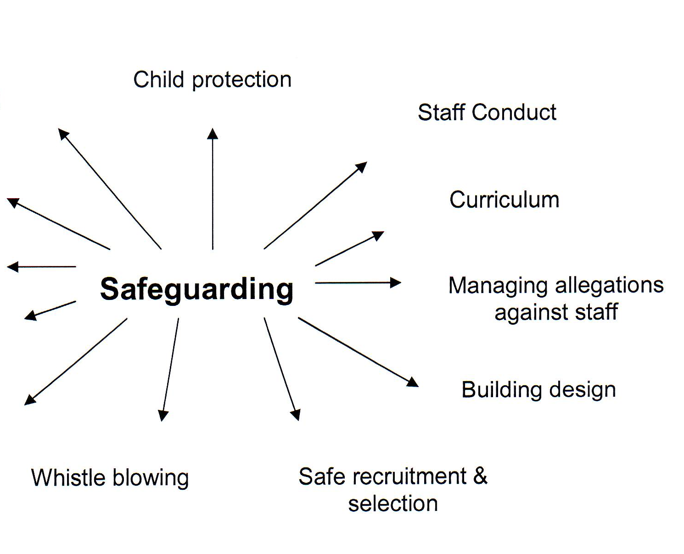

Anti-bullying
Policies

On-line
Safety

Attendance

Behaviour
Management

Health & Safety
PROVIDING A SAFE AND SUPPORTIVE ENVIRONMENT

- Safer Recruitment and Selection

This school is committed to safeguarding and promoting the welfare of children and young people and expects all staff and volunteers to share this commitment

We ensure that all appropriate measures are applied in relation to everyone who works in the school who is likely to be perceived by the children as a safe and trustworthy adult including volunteers, governors and staff employed by contractors. Safer recruitment practice includes scrutinising applicants, verifying identity and academic or vocational qualifications, obtaining professional references, checking previous employment history and ensuring that a candidate has the health and physical capacity for the job. It also includes undertaking interviews and, where appropriate, undertaking an enhanced (DBS) check to check against the barred list.

In line with statutory changes, underpinned by regulations, the following will apply:

- a DBS Enhanced Disclosure is obtained for all new appointments to our school’s workforce (unless portability applies, e.g. supply teachers);
- this school is committed to keep an up to date single central record detailing a range of checks carried out on our staff;
- all new appointments to our school workforce who have lived outside the UK will be subject to additional checks as appropriate;
- our school ensures that supply staff have undergone the necessary checks and will be made aware of this policy;
- identity checks must be carried out on all appointments to our school workforce before the appointment is made, in partnership with the Local Authority.

2 Safe Practice

Our school will follow the Safeguarding Children and Young People in Educational Settings policy and procedures along with guidance provided by the Gwent Safeguarding Board.

gwentsafeguarding.org.uk/en/protocols-and-procedures

Safe working practice ensures that pupils are safe and that all staff:

- are responsible for their own actions and behaviour and should avoid any conduct which would lead any reasonable person to question their motivation and intentions;

- work in an open and transparent way;

- work with other colleagues where possible in situations open to question;

- discuss and/or take advice from school management over any incident which may give rise to concern;

- record any incidents or decisions made;
- apply the same professional standards regardless of gender or sexuality;
- be aware of the confidentiality policy;

- are aware that breaches of the law and other professional guidelines could result in criminal and/or disciplinary action being taken against them.

3 Safeguarding Information for pupils

All pupils in our school are aware of a number of staff who they can talk to. Our school is committed to ensuring that pupils are aware of behaviour towards them that is not acceptable and how they can keep themselves safe. All pupils know that we have a senior member of staff with responsibility for child protection and know who this is. We inform pupils of whom they might talk to, both in and out of school, their right to be listened to and heard and what steps can be taken to protect them from harm.

Our school will ensure that pupils are made aware that information can be found at the following: Posters displayed for Child Helpline and NSPCC, Year 6 attend Crucial Crew, pupils have regular visits from the Gwent Police Education Liaison Officer. The NSPCC come to school every 2 years to give an assembly followed by workshops presenting the ‘speak out’ stay safe programme.
School’s arrangements for consulting with and listening to pupils are supported by regular assemblies informing children of resources ans staff who will provide support eg Trauma informed practioner, trauma teddies/worry bears, ELSA and therapy sessions including ‘Sand Play Therapy’
We make pupils aware of these arrangements by talking about them in assemblies, class and having awareness posters around the school.

4 Partnership with Parents

The school shares a purpose with parents to educate and keep children safe from harm and to have their welfare promoted. St David’s RC Primary School has an ‘open door’ policy and parents know they can come into school without an appointment to discuss concerns. Parents have been informed we are an Operation Encompass School and information is on our website relating to our Safe Guarding Procedures.

We are committed to working with parents positively, openly and honestly. We ensure that all parents are treated with respect, dignity and courtesy. We respect parents’ rights to privacy and confidentiality and will not share sensitive information unless we have permission or it is necessary to do so in order to protect a child.

St Davids RC Primary School will share with parents any concerns we may have about their child unless to do so may place a child at risk of harm.

We encourage parents to discuss any concerns they may have with the schools Safe Guarding Officers, or Chair of Governors, names are displayed around the school and on our website.

We make parents aware of our safeguarding policy which is on our website and parents are made aware that they can view this policy on request.

Sample Insert for School Brochure

St Davids RC Primary School is committed to ensuring the welfare and safety of all children in school. All Torfaen schools, including St Davids RC Primary School, follow the Gwent Safeguarding Board procedures. The school will, in most circumstances, endeavour to discuss all concerns with parents about their children. However, there may be exceptional circumstances when the school will discuss concerns with Social Care and/or the Police without parental knowledge (in accordance with Child Protection procedures). The school will, of course, always aim to maintain a positive relationship with all parents. The school’s child protection policy is available on request.

5 Partnerships with Others

Our school recognises that it is essential to establish positive and effective working relationships with other agencies who are partners in the Gwent Safeguarding Board. As a school we promote a safe and supportive environment, posters are displayed with helpline numbers for children. eg NSPCC help line number, Child line, Torfaen Counselling services and Barnardo’s and Operation Encompass. We have regular visits from Gwent Liaison Officer and the Young Carers Association There is a joint responsibility on all these agencies to share information to ensure the safeguarding of all children.

6 School Training and Staff & Governor Induction

The school’s senior member of staff with designated responsibility for child protection (DSP) and their deputy undertakes safeguarding training to support them in carrying out their role and this is refreshed every 2 years. In addition training in inter–agency working is undertaken to ensure continual professional development and that skills and knowledge in child protection are always up to date.

The Head teacher and all other school staff, including non-teaching staff, undertake appropriate induction training to equip them to carry out their responsibilities for child protection effectively. This training is repeated formally every 3 years and refreshed at least annually.

The SCG and COG receive training to support them in undertaking their roles which is refreshed every two years. All other governors also receive appropriate safeguarding training.

The Keeping Learners Safe Modules available on Hwb support all staff, volunteers and governors to understand their safeguarding responsibilities as set out in the Keeping Learners Safe Guidance.

All staff, governors and volunteers are provided with the school’s child protection policy and informed of school’s child protection arrangements on induction.

7 Support, Advice and Guidance for Staff

Staff will be supported by St David’s RC Primary school, LA and professional associations.

The designated safeguarding person for Safeguarding/Child Protection (DSP) will be supported by Marie Gunter, Sian Morgan, Naomi Bowen, Karen Robinson and Richard Dobbs

8 Children Missing from Education

When a child on roll at a school appears to have gone missing or is withdrawn from a maintained school in Wales without the parent/carer giving notice or without the school being advised of the new school, the school should try to make contact with the parent/carers. Care should be taken to record all the steps taken to locate the child such as information known, received, dates, times and people spoken to along with decisions and actions taken. If these efforts fail, the school should notify the Education Welfare Service promptly who will then work with the school and make every effort to try and identify the child or young person’s current whereabouts/destination. If a child or young person has left school without a known destination and both school and the Education Welfare Service have followed procedures and all ‘reasonable efforts’ to locate them have been unsuccessful, then, after a minimum period of 20 days, the school, in consultation with the Local Authority should remove the child or young person’s name from its roll and create a ‘lost pupil’ common transfer file (CTF) with XXXXXXX as the destination. The CTF should be uploaded onto the s2s secure site where it will be held in the ‘lost pupil’ area.

9 Confidentiality

The school has adopted the LA’s Data Protection Policy and has a Code of Conduct which describes our expectations of staff.

Where there is a concern that a child may be suffering or is at risk of suffering significant harm, the child’s safety and welfare must be the overriding consideration.

Confidentiality is important in maintaining confidence and participation in services and thereby helping to protect children’s’ health and well-being. However, the duty of confidentiality is not absolute and may be breached where this is in the best interest of the child and in the wider public interest.

10 Pupil Information

Our school will endeavour to keep up to date and accurate information in order to keep children safe and provide appropriate care for them the school requires accurate and up to date information regarding:

- names and contact details of persons with whom the child normally lives;

- names and contact details of all persons with parental responsibility (if different from above);

- emergency contact details (if different from above);

- details of any persons authorised to collect the child from school (if different from above);

- any relevant court orders in place including those which affect any person’s access to the child (e.g. Residence Order, Contact Order, Care Order, Injunctions etc.);
- if the child is or has been on the Child Protection Register or subject to a care plan:

- name and contact detail of G.P.

- any other factors which may impact on the safety and welfare of the child

- The school will collate, store and agree access to this information.

- Pupils’ records are stored electronically and on paper, paper documents are kept in locked files.
…………………………………………………….

11 Roles and Responsibilities

Our Governing Body will ensure that:

- the school has a child protection policy and procedures in place that are in accordance with Local Authority guidance and locally agreed inter-agency procedures, and the policy is made available to parents on request;

- the school operates safe recruitment procedures and makes sure that all appropriate checks are carried out on staff and volunteers who work with children;

- the school has procedures for dealing with allegations of abuse against staff and volunteers that comply with guidance from the Local Authority and locally agreed inter-agency procedures;

- a senior member of the school’s leadership team is designated to take lead responsibility for child protection (and deputy);

- A lead governor is nominated to ensure safeguarding is receiving proper attention – the Safeguarding Children Governor (SCG)

- staff undertake appropriate child protection training;

- they remedy, without delay, any deficiencies or weaknesses regarding safeguarding arrangements;

- a governor is nominated (typically the Chair of Governors) to be responsible for liaising with the LA and /or partner agencies in the event of allegations of abuse being made against the head teacher

- where services or activities are provided on the school premises by another body, the body concerned has appropriate policies and procedures in place in regard to safeguarding children and child protection and liaises with the school on these matters where appropriate.

- they review their policies and procedures annually and provide information to the Local Authority about them and about how the above duties have been discharged

Our Head teacher will ensure that:

- the policies and procedures adopted by the Governing Body are fully implemented, and followed by all staff;

- sufficient resources and time are allocated to enable the designated person and other staff to discharge their responsibilities; and

- all staff and volunteers feel able to raise concerns about poor or unsafe practice in regard to children, and such concerns are addressed sensitively and effectively in a timely manner in accordance with agreed whistle blowing policies.

Senior Member of Staff with Designated Responsibility for Child Protection (Designated Safeguarding Person DSP) will:

- take responsibility for Child Protection practice, policy and procedures and professional development working with other agencies as necessary

- refer cases of suspected abuse or allegations to the relevant investigating agencies as soon as a problem, suspicion or concern about a child becomes apparent and certainly within 24 hours

- ensure referrals made by telephone or in person are confirmed in writing within 24 hours using the Duty to Report - Multi Agency Referral Form (MARF)

- act as a source of support , advice and expertise within the educational establishment;

- liaise with the Head teacher to inform him/her of any issues and ongoing investigations and ensure there is always cover for this role.

- recognise how to identify signs of abuse and when it is appropriate to make a referral;

- have a working knowledge of the Gwent Safeguarding Board, the conduct of a child protection case conference and be able to attend and contribute to these;

- ensure that all staff have access to and understand the school’s child protection policy;

- Support the Head teacher and governing body in ensuring the school has robust safe recruitment and retention procedures

- ensure that all staff have induction training;

- keep detailed accurate secure written records and/or concerns

- obtain access to resources, attend any relevant or refresher training courses at least every two years and ensure the learning from the training is cascaded to all staff as necessary within the school.

- ensure the child protection policy is updated and reviewed annually and work with the Governing Body regarding this;

- ensure parents are made aware of the child protection/ safeguarding policy which alerts them to the fact that referrals may be made and the role of the establishment in this to avoid conflict later;

- where a child leaves the school/setting, ensure the child protection file is copied for the new school/setting asap and transferred to the new school separately from the main pupil file in accordance with the LA School’s Retention Policy. If a child goes missing or leaves to be educated at home, then the child protection file should be copied and the copy forwarded to the Education inclusion Service.

All staff and volunteers will:

- fully comply with the school’s policies and procedures

- attend appropriate training

- inform the designated person of any concerns

Staff And Volunteers Should Never:

- Engage in sexually provocative or rough physical games, including horse play.
- Allow children to use inappropriate language unchallenged.
- Make sexually suggestive comments in front of, about, or to a child, even in “fun”.
- Let allegations made by a child go without being addressed and recorded
- Deter children from making allegations through fear of not being believed.
- Do things of a personal nature for children that they can do themselves.
- Share a bedroom with a child or young person.
- Invite or allow a child or young person to stay with them at their home unsupervised.
- Jump to conclusions about others without checking facts.
- Rely on their own good name to protect them

IDENTIFYING CHILDREN AND YOUNG PEOPLE WHO MAY BE SUFFERING SIGNIFICANT HARM

Teachers and other adults in school are well placed to observe any physical, emotional or behavioural signs which indicate that a child may be suffering significant harm. The relationships between staff, pupils, parents and the public which foster respect, confidence and trust can lead to disclosures of abuse, and/or school staff being alerted to concerns.
Definitions

As in the Children Acts 1989 and 2004, a child is anyone who has not yet reached his/her 18th birthday.

Harm means ill-treatment or impairment of health and development, including, for example, impairment suffered from seeing or hearing the ill-treatment of another; Development means physical, intellectual, emotional, social or behavioural development; Health includes physical and mental health; Ill-treatment includes sexual abuse and other forms of ill-treatment which are not physical.

Abuse and Neglect are forms of maltreatment. Somebody may abuse or neglect a child by inflicting harm or failing to act to prevent harm. Children may be abused in a family or in an institutional or community setting; by those known to them, or, more rarely, by others (e.g. via the internet). They may be abused by an adult or adults or another child or children.

Physical Abuse may involve hitting, shaking, throwing, poisoning, burning or scalding, drowning, suffocating or otherwise causing physical harm to a child. Physical harm may also be caused when a parent or carer fabricates the symptoms of, or deliberately induces, illness in a child.

Sexual Abuse involves forcing or enticing a child or young person to take part in sexual activities, not necessarily involving a high level of violence, whether or not the child is aware of what is happening. The activities may involve physical contact, including penetrative (e.g. rape, or oral sex) or non-penetrative acts. They may include non-contact activities, such as involving children in looking at, or in the production of, sexual images, watching sexual activities, encouraging children to behave in sexually inappropriate ways or grooming a child in preparation for abuse (including via the internet). Sexual abuse is not solely perpetrated by adult males. Women can also commit acts of sexual abuse, as can other children.

Emotional Abuse is the persistent emotional maltreatment of a child such as to cause severe and persistent adverse effects on the child’s emotional development. It may involve conveying to children that they are worthless or unloved, inadequate, or valued only insofar as they meet the needs of another person. It may include not giving the child opportunities to express their views, deliberately silencing them or ‘making fun’ of what they say or how they communicate. It may feature age or developmentally inappropriate expectations being imposed on children. These may include interactions that are beyond the child’s developmental capability, as well as overprotection and limitation of exploration and learning, or preventing the child participating in normal social interaction. It may involve seeing or hearing the ill treatment of another. It may involve serious bullying (including cyber bullying) causing children frequently to feel frightened or in danger, or the exploitation or corruption of children. Some level of emotional abuse is involved in all types of maltreatment of a child, though it may occur alone.

Neglect is the persistent failure to meet a child’s basic physical and/or psychological needs, likely to result in the serious impairment of the child’s health or development. Neglect may occur during pregnancy as a result of maternal substance abuse. Once a child is born, neglect may involve a parent or carer failing to provide adequate food and clothing, shelter (including exclusion from home or abandonment), protect a child from physical and emotional harm or danger, ensure adequate supervision (including the use of inadequate carers), or ensure access to appropriate medical care or treatment. It may also include neglect of, or unresponsiveness to, a child’s basic emotional needs.

Child Sexual Exploitation is a form of child sexual abuse. It occurs where an individual or group takes advantage of an imbalance of power to coerce, manipulate or deceive a child or young person under the age of 18 into sexual activity, (a) in exchange for something the victim needs or wants and/or (b) for the financial advantage or increased status of the perpetrator or facilitator. The victim may have been sexually exploited even if the sexual activity appears consensual. Child sexual exploitation does not always involve physical contact, it can also occur through the use of technology.

Child Criminal Exploitation is common in county lines and occurs when an individual or group takes advantage of an imbalance of power to coerce, control, manipulate or deceive a child or young person under the age of 18. The victim may have been criminally exploited even if the activity appears consensual. Child Criminal Exploitation does not always involve physical contact, it can also occur through the use of technology,

The UK Government defines county lines as the term used to describe gangs and organised criminal networks involved in exporting illegal drugs into one or more importing areas within the UK, using dedicated mobile phone lines or other form of ‘deal line’. They are likely to exploit children and vulnerable adults to move and store the drugs or money and they will often use coercion, intimidation, violence (including sexual violence) and weapons.

Online Abuse – Online abuse is abuse that is facilitated using technology. It may take place through social media, online games, or other channels of digital communication. Children can also be re-victimised if evidence of their abuse is recorded or uploaded online. Technology can facilitate a number of illegal abusive behaviours including, but not limited to: harassment; stalking; threatening behaviour; sharing indecent images of children under 18; inciting a child to sexual activity; sexual exploitation; grooming; sexual communication with a child; and, causing a child to view images or watch videos of a sexual act. Using technology to facilitate any of the above activities is online abuse. Alongside those illegal activities that are perpetrated online, children may also be exposed to inappropriate behaviours or content online. For instance, children may be bullied online by their peers or they might, either accidentally or intentionally, view content which is intended for adults, such as pornography. Both online abuse and exposure to unsuitable content or behaviour can have a long lasting impact on the wellbeing of children and young people.

TAKING ACTION TO ENSURE THAT CHILDREN ARE SAFE
AT SCHOOL AND AT HOME

All staff follow the Gwent Safeguarding Board Child Protection Procedures which are consistent with ‘Working Together to Safeguard Children’ and the Wales Safeguarding Procedures.

It is not the responsibility of the school staff to investigate welfare concerns or determine the truth of any disclosure or allegation. All staff, however, have a duty to recognise concerns and maintain an open mind. Accordingly all concerns regarding the welfare of pupils will be recorded and discussed with the designated safeguarding person with responsibility for child protection (or another senior member of staff in the absence of the designated person) prior to any discussion with parents.

Our school fully recognises the contribution it makes to child protection and the following procedures will be followed in relation to concerns of a child protection nature in this school:

There are three main elements to our child protection policy and procedures:

- Prevention through the culture, teaching and pastoral support offered to pupils
- Procedures for identifying and reporting cases, or suspected cases, of abuse. Because of our day to day contact with children school staff are well placed to observe the outward signs of abuse
- Support to pupils who may have been abused.

Our policy and procedures apply to all staff and volunteers working in the school and governors. Learning support assistants, midday supervisors, caretakers and secretaries as well as teachers can be the first point of disclosure for a child.

Prevention

We recognise that high self-esteem, confidence, supportive friends and good lines of communication with a trusted adult helps to safeguard pupils. The school will therefore:

- Establish and maintain an ethos where children feel secure and are encouraged to talk, and are listened to
- Ensure children know that there are adults in the school whom they can approach if they are worried or in difficulty
- Include in the curriculum, activities and opportunities for relationships and sexuality education which equip children with the skills they need to stay safe from abuse and to know to whom to turn for help
- Include in the curriculum, material which will help children develop realistic attitudes to the responsibilities of adult life, particularly with regard to childcare and parenting skills
- build relationships with other agencies and ensure early and appropriate referrals for support and intervention are made before risks escalate
- take a whole-school (setting) approach to well-being which will incorporate safeguarding and preventative measures to support children and families.

Procedures

We will follow the Wales Safeguarding Procedures that have been endorsed by the Gwent Safeguarding Board and as required in WG Guidance Keeping Learners Safe the school will ensure:

- It has a designated governor, the Safeguarding Children Governor (SCG) who will oversee the school’s safeguarding policy and provide a supporting link for the DSP
- it has a designated safeguarding person (DSP) for safeguarding who has undertaken appropriate training
- it recognises the role of the DSP and arrange support for training

- Every member of staff and every governor knows:

    - the name of the DSP and their role, the local authority point of contact and the designated governor for safeguarding
    - that they have an individual responsibility for reporting children at risk and protection concerns to the MASSH, or to the police, within the timescales agreed with the Regional Safeguarding Board

    - How to take forward concerns where the DSP is not available

  - Ensure that members of staff are aware of the need to be alert to signs of abuse or neglect and know how to respond to a pupil who may disclose abuse or neglect

- Ensure that members of staff who are EWC registrants are aware of the Code of Professional Conduct and Practice for registrants with the Education Workforce Council www.ewc.wales/site/index.php/en/fitness-to-practise/code-of-professional-conduct-and-practice-pdf and the expectation within the Code that the registrant has regard to the safety and well-being of learners in their care and related content

  - Provide training for all staff so that they:

    - understand their personal responsibility
    - ‒ know the agreed local procedures and their duty to respond
    - ‒ are aware of the need to be vigilant in identifying cases of abuse and neglect
    - ‒ know how to support a child who discloses abuse or neglect
    - ‒ understand the role online behaviours may have in each of the above

  - Notify the local MASSH if

- A pupil on the child protection register is excluded either for a fixed term or permanently
- If there is an unexplained absence of a pupil on the child protection register of more than two days duration from school (or one day following a weekend)

- Work to develop effective links with relevant agencies and co-operate as required with their enquiries regarding child protection matters including attendance at initial review as well as child protection conferences and core groups and the submission of written reports to the conferences

- Keep written records of concerns about children and ensure all records are kept secure and in locked locations (noting the date, event and action taken), even where there is no need to refer the matter to the local authority immediately

- Adhere to the procedures set out in the Welsh Government‘s Disciplinary and dismissal procedures for school staff: Revised guidance for governing bodies
https://gov.wales/disciplinary-and-dismissal-procedures-school-staff

- Ensure that recruitment and selection procedures are made in accordance with WG guidance – Keeping Learners Safe

Supporting the pupil at risk

In line with the Future Generations (Wales) Act 2015, schools and colleges should maintain an emphasis on prevention, in terms of early intervention, with a view to reducing the risks children are exposed to and subsequent difficulties in later life. Exposure to adverse childhood experiences (ACE’s) is associated with poorer health and well-being outcomes. Early identification, intervention and action to mitigate the impact of ACE’s, across the life course, is vital. ACE’s are traumatic experiences that occur before the age of 18 and are remembered throughout adulthood. They may include child maltreatment such as physical, sexual, verbal abuse and neglect and wider experiences of household dysfunction, such as growing up in a household affected by domestic violence, parental separation, alcohol and drug use, mental illness or parental incarceration. We recognise that children who are at risk, suffer abuse or witness violence may be deeply affected by this and this school may be the only stable, secure and predictable element in the lives of children at risk. When at school their behaviour may be challenging and defiant or they may be withdrawn. The school will endeavour to support the pupil through:

- the content of the curriculum to encourage self-esteem and self-motivation

- the school ethos which :

  - promotes a positive, supportive and secure environment
  - gives pupils a sense of being valued

- the school behaviour policy, which is aimed at supporting vulnerable pupils in the school. All staff will agree on a consistent approach that focuses on the behavioural outcome of the child but does not damage the individual’s sense of self-worth. The school will endeavour to ensure that the learner knows that some behaviour is unacceptable but that they are valued and not to be blamed for any abuse which has occurred

- liaison with other agencies who support the pupil such as local authority officers – for example the educational psychology service, behaviour support services or the Education Welfare Service – child and adolescent mental health services, and advocacy services
- keeping records and notifying the local authority as soon as there is a recurrence of a concern.

- When a learner on the child protection register leaves, we will transfer information to the new provider immediately and inform social care.

Violence Against Women Domestic Abuse and Sexual Violence (VAWDASV)

Our school is aware that violence against women, domestic abuse and sexual violence
can have a huge impact on children and young people and can affect their safety, health
and wellbeing, educational attainment, family and peer relationships and their ability to
enjoy healthy, respectful relationships in the future. We are committed to a whole school
approach to tackling this as set out in the Good Practice Guide – A Whole School Approach to VAWDASV in Wales https://gov.wales/live-fear-free?policies-and-guidance/good-practice-guide-a-whole-education-approach and pupils are supported via the curriculum by providing age appropriate healthy relationship lessons and staff and governors are encouraged to undertake training in line with the National Training Framework..

Operation Encompass
Our school supports Operation Encompass which is a police and education early intervention safeguarding partnership. Gwent Police informs relevant primary and secondary schools of any incident of domestic abuse which is experienced by or involves a child or young person. This approach enables our school to provide the most appropriate support and creates a trusting environment for all children or young people following any incident.

Safeguarding Pupils who are Vulnerable to Extremism - the Prevent Duty

Our school/setting values the fundamental rights of freedom of speech, expression of beliefs and ideology and tolerance of others which are the core values of our democratic
society. However, all rights come with responsibilities and free speech or beliefs designed to manipulate the vulnerable or which advocate harm or hatred towards others will not be tolerated. We always seek to protect our pupils and staff from all messages and forms of extremism and ideologies. We use opportunities within the curriculum to explore and challenge these topics and to promote the values of democracy and mutual respect and tolerance of different faiths and beliefs.

Our school/setting is clear that exploitation and radicalisation will be viewed as a safeguarding concern and will be referred to the appropriate safeguarding agencies.

The school has a risk assessment in place in line with the Prevent Duty and all staff with designated safeguarding responsibilities have received training in relation to the Prevent Duty which is refreshed every 2 years. As with any other safeguarding risks they are aware they must bring concerns to the attention of the DSP who will take appropriate action. See Appendix 7.

Female Genital Mutilation (FGM) Mandatory Reporting Duty

On 31st October 2016 a new duty was introduced that requires health and social care
professionals and teachers to report known cases of FGM in girls under 18 to the police.

In the UK all forms of FGM are illegal under the FGM Act 2003 and our school follows Home Office multi agency guidelines which outline the actions that should be taken by frontline professionals including teachers, to protect girls and women and offer them the support they need. The Wales Safeguarding Procedures Protocol on FGM also provides advice on safeguarding girls from FGM.

Any information or concern that a child is at immediate risk of, or has undergone FGM will result in an immediate child protection referral.

Harmful Sexual Behaviour

Sexual abuse can happen between children of any age and sex, and takes many forms along a continuum ranging from sexual harassment through to contact sexual abuse, including peer sexual exploitation and harmful sexual behaviour. Peer sexual abuse involves children of similar ages/year groups whereas other types of harmful sexual behaviour will involve a large difference in age. Increasingly, peer sexual abuse is taking place through digital platforms, which makes it more complex for education settings to tackle. We recognise there is a continuum of behaviours which constitute peer sexual abuse, exploitation and harmful sexual behaviour. We will respond to all behaviours in a proportionate way and in in line with WG’s Peer on Peer Sexual Harassment in education settings Action Plan (Jan 24). We continue to ensure a whole school approach to creating healthy, respectful relationships between peers is embedded within our school and implement appropriate safeguarding and child protection procedures as required.

Children with Additional Learning Needs

We recognise that statistically children with behavioural difficulties and disabilities are
most vulnerable to abuse. School staff who deal with children with profound and multiple disabilities, sensory impairment and or emotional and behaviour problems need to be particularly sensitive to signs of abuse.

Staff must immediately report:

- any suspicion that a child is injured, marked, or bruised in a way which is not readily attributable to the normal knocks or scrapes received in play

- any explanation given which appears inconsistent or suspicious

- any behaviours which give rise to suspicions that a child may have suffered harm (e.g. worrying drawings or play)

- any concerns that a child may be suffering from inadequate care, ill treatment, or emotional maltreatment

- any concerns that a child is presenting signs or symptoms of abuse or neglect

- any significant changes in a child’s presentation, including non-attendance

- any hint or disclosure of abuse from any person

- any concerns regarding person(s) who may pose a risk to children (e.g. living in a household with children present)

Responding to Disclosure

Disclosures or information may be received from pupils, parents or other members of the public. School recognises that those who disclose such information may do so with difficulty, having chosen carefully to whom they will speak. Accordingly all staff will handle disclosures with sensitivity (insert school arrangements to ensure that pupils with communication difficulties are enabled to express themselves to a member of staff with appropriate skills) ……………………………………………………

Such information cannot remain confidential and staff will immediately communicate what they have been told to the designated person and make an immediate record. Children who have made a disclosure should not be re-interviewed by school staff – a child protection referral should be made.

Staff will not investigate but will, wherever possible, elicit enough information to pass on to the designated person in order that s/he can make an informed decision of what to do next.

Staff will:

- listen to and take seriously any disclosure or information that a child may be at risk of harm

- try to ensure that the person disclosing does not have to speak to another member of school staff

- clarify the information

- try to keep questions to a minimum and of an ‘open’ nature e.g. ‘Can you tell me what happened?’ rather than ‘Did x hit you?’

- try not to show signs of shock, horror or surprise

- not express feelings or judgements regarding any person alleged to have harmed the child

- explain sensitively to the person that they have a responsibility to refer the information to the safeguarding designated person

- reassure and support the person as far as possible

- explain that only those who ‘need to know’ will be told

- explain what will happen next and that the person will be involved as appropriate

Actions by the DSP

Following any information raising concern, the DSP will consider:

- any urgent medical needs of the child

- consulting with appropriate persons e.g. Safeguarding Officer, Social Care

- the child‘s wishes

Then decide:

- wherever possible, to talk to parents, unless to do so may place a child at risk of significant harm, impede any police investigation and/or place the member of staff or others at risk
- whether to make a child protection referral to social care because a child is suffering or is likely to suffer significant harm and if this needs to be undertaken immediately

OR

- not to make a referral at this stage

- if further monitoring is necessary

- All information and actions taken, including the reasons for any decisions made, will be fully documented. All referrals to social care will be accompanied by a standard Duty to Report referral form (MARF).

Action following a child protection referral

The DSP or other appropriate member of staff will:

- make regular contact with the Social worker involved to stay informed

- wherever possible, contribute to the Strategy Discussion

- provide a report for, attend and contribute to any subsequent Child Protection Conference

- if the child or children are placed on the Child Protection Register, contribute to the Child Protection Plan and attend Core Group Meetings and Review Child Protection Conferences

- where possible, share all reports with parents prior to meetings

- where in disagreement with a decision made e.g. not to apply Child Protection Procedures or not to convene a Child Protection Conference, discuss this with the Safeguarding Manager of Torfaen Safeguarding Unit.

- where a child on the child protection register moves from the school or goes missing, immediately inform the key worker in Social Care

Recording and monitoring

Accurate records will be made as soon as practicable and will clearly distinguish between observation, fact, opinion and hypothesis. All records will be signed and dated, any information given will be recorded verbatim where possible and a note made of the location and description of any injuries seen.

All child protection documents will be retained in a ‘Child Protection’ file, separate from the child’s main file. This will be locked away and only accessible to the Head teacher and DSP. These records will be copied and transferred to any school or setting the child moves to, clearly marked ‘Child Protection, Confidential, for attention of Child Protection Coordinator (See Appendix 8). If the child goes missing from education or is removed from roll to be educated at home then any Child Protection file should be copied and the copy sent to the Educational Welfare Service. Original copies will be retained until the child’s 25th birthday – these should be retained by the school.

Supporting the Child and Partnership with Parents

School recognises that the child’s welfare is paramount, however good child protection practice and outcome relies on a positive, open and honest working partnership with parents

Whilst we may, on occasion, need to make referrals without consultation with parents, we will make every effort to maintain a positive working relationship with them whilst fulfilling our duties to protect any child

We will provide a secure, caring, supportive and protective relationship for the child

Children will be given a proper explanation (appropriate to age & understanding) of what action is being taken on their behalf and why

We will endeavour always to preserve the privacy, dignity and right to confidentiality of the child and parents. The DSP will determine which members of staff “need to know” personal information and what they “need to know” for the purpose of supporting and protecting the child
Allegations regarding person(s) working in or on behalf of school (including volunteers)
Where an allegation is made against any person working in or on behalf of the school that he or she has:
- Behaved in a way that has harmed a child or may have harmed a child
- Possibly committed a criminal offence against or related to a child or
- Has behaved towards a child or children in a way that indicates s/he is unsuitable to work with children.
We will apply the same principles as in the rest of this document and we will always follow the Gwent Safeguarding Board procedures. Our school disciplinary procedures also reflect these requirements.
Detailed records will be made to include decisions, actions taken, and reasons for these. All records will be retained securely (insert arrangements………………………..)
Whilst we acknowledge such allegations, (as all others), may be false, malicious or misplaced, we also acknowledge they may be founded. It is, therefore, essential that all allegations are investigated properly and in line with agreed procedures.
(School may wish to expand this section to include procedures with reference to Gwent Safeguarding Board Procedures and Torfaen Disciplinary Procedures).
Safeguarding Responsibilities in Specific Circumstances

There are many additional considerations in relation to specific safeguarding issues and a wealth of guidance exists which schools must follow to meet their safeguarding duties and responsibilities. Examples of specific issues are:

Abuse by children and young people
Asylum seeking children
Black Minority Ethnic Pupils
Bullying
Child Abuse images and the internet
Child Abuse linked to witchcraft and spiritual beliefs
Child Neglect
Children and young people in the youth justice system
Children living away from home or in temporary accommodation
Child Criminal Exploitation (CCE)
Child Sexual Exploitation (CSE)
Children who may have been trafficked
Children missing education
Children who run away/missing
Disabled children
On-line safety
Fabricated or induced illness
Female Genital Mutilation
Forced marriage and honour based violence
Foster care including private fostering
Foreign exchange visits
Gender based violence, domestic abuse and sexual violence
Physical contact with pupils, including restraint
Radicalisation
Sexually active young people
Substance misuse
Suicide
Teenage intimate partner abuse

Schools should therefore refer to WG Guidance 272/2021 Keeping Learners Safe for links to statutory and good practice guidance on specific safeguarding issues.

Other Useful Contacts

Gwent Safeguarding Board – www.gwentsafeguarding.org.uk

Violence Against Women, Domestic Abuse and Sexual Violence (VAWDASV) – Vawdasv Gwent – Vawdasv.Gwent@newport.gov.uk

Community Safety Team – CommunitySafetyTeam@torfaen.gov.uk

NSPCC – www.nspcc.org.uk

ChildLine – www.childline.org.uk

Children in Wales - www.childreninwales.org.uk

Hwb Digital Learning for Wales – Hwb (gov.wales)

Domestic Violence - Live Fear Free - www.livefearfree.gov.wales

Internet Safety - SWGfL - www.swgfl.org.uk

Appendix 1

Legislative Framework

Legislation underpins Torfaen LA’s Safeguarding Policy & Procedures.

CHILDREN ACT 1989

Section 47 places a duty on:

- any local authority;
- any local education authority;
- any housing authority;
- any health authority, Special Health Authority or National Health Service Trust; and
- any person authorised by the National Assembly for Wales

to help a Local Authority with its enquiries in cases where there is reasonable cause to suspect that a child is suffering, or is likely to suffer, significant harm.

Meaning of "harm"

"Harm" is defined in section 31(9) of the Children Act 1989 as "ill-treatment or the impairment of health or development". It is broader than physical violence and includes sexual abuse and forms of ill-treatment which are not physical. Any harm a child suffers because a parent is being harassed or intimidated is caught by the definition of "harm". Section 120 of the Adoption and Children Act 2002 amends the definition of harm in the Children Act 1989 to "ill-treatment or the impairment of health or development, including, for example, impairment suffered from seeing or hearing the ill-treatment of another".

CHILDREN ACT 2004
The Children Act (2004) sets out the framework for all services working with children, safeguarding children being recognised as a key area which is now a central responsibility of all agencies under the scrutiny of the Local Safeguarding Children’s Board.

The Children Act 2004 strengthens the arrangements for protecting and promoting the Welfare of children and young people. It places a duty on all local authorities in Wales to make arrangements to promote co-operation with a view to improving the well-being of children in their area, in relation to:

- Physical & mental health and emotional well-being.
- Protection from harm and neglect.
- Education, training and recreation.
- The contribution made by them to society.
- Social and economic well-being.

EDUCATION ACT 2002

Section 175 of the Education Act 2002 places a statutory duty on LAs and the Governing Bodies of all schools and further education institutions to make arrangements to ensure that their functions are carried out with a view to safeguarding and promoting the welfare of children. In addition, these bodies must have regard to any guidance issued by the Secretary of State in considering what arrangements they need to make under Section 175.

Section 157 places the same duties on the proprietors of all independent schools and colleges.

‘Everyone in the Education Service shares an objective to help keep children and young people safe by contributing to:

Providing a safe environment for children and young people to learn in education settings; and
Identify children and young people who are suffering or likely to suffer significant harm, and taking appropriate action with the aim of making sure they are kept safe both at home and at school’.

(Safeguarding Children in Education Guidance, 2004)

HUMAN RIGHTS ACT 1998 AND DATA PROTECTION 1998

The Children Act 1989 and Human Rights Act 1998 have changed the way referrals to Social Care are made. Parents now have a right to know that their child is being referred – unless it is reasonable to assume that informing the parents will place the child in danger or that it would lead to the destruction of evidence – this is most likely in cases of alleged physical or sexual abuse.

A child can bring an action for damages against a Local Authority in their own right rather than through their parents. The child when an adult can bring a claim within three years of the injury coming to their attention, but can be extended by the court if leave is granted. If bringing an action as a child it can be for the parents or a guardian to do this. This means that pupil records should be kept for nine years after the child has left school (as a minimum).

Data protection legislation means that parents/former pupils have the right to see their school records and although child protection information is exempt from this requirement, if a parent or former pupil asked to see notes registering any child protection concerns, then it is likely that a Local Authority would be obliged to show them, unless to do so would cause individual harm to the parent or former pupil, unless the case had involved a criminal prosecution, care order or other legal prohibition. Therefore, it is vital that all information written about children, or allegations made by children is kept to objective comments, verbatim accounts and factual information.

Before disclosing any information as an access request you should follow Torfaen’s County Borough Council’s procedure. If in doubt contact the Council’s Information Security Manager or Legal Services SEXUAL OFFENCES ACT 2003

The Sexual Offences Act 2003 has established a new legal framework for defining acceptable and unacceptable relationships. It clarifies that it is inappropriate for any education professional to form an intimate relationship with a young person under 18. This is clearly stated in the LA’s Code of Conduct. It makes new provision about sexual offences including those against children.

THE EQUALITY ACT 2010The Equality Act 2010 imposes statutory duties on local authorities and educational establishments so that all schools in Wales, irrespective of how they are funded or managed, have obligations under the Equality Act 2010 as employers, service providers and bodies which carry our public functions.

THE SOCIAL SERVICES AND WELL-BEING ACT 2014

The Social Services and Well-being Act 2014 came into force on 6 April 2016. The Act is a pivotal delivery mechanism for implementing and strengthening key aspects of the Welsh Government’s safeguarding agenda. The scope of the Act extends beyond social services. It sets out the responsibilities in terms of the promotion of well-being and places a duty on local authorities to arrange or provide services which contribute to the prevention of abuse and neglect. It has strengthened arrangements for adult safeguarding and protection and enhances the wellbeing for people who need care and support, and carers who need support by providing a core legislative framework to underpin policy objectives.

THE VIOLENCE AGAINST WOMEN, DOMESTIC ABUSE AND SEXUAL VIOLENCE (WALES) ACT 2015 (VAWDASV)

The Violence Against Women, Domestic Abuse and Sexual Violence (Wales) Act 2015 introduces requirements for relevant authorities to prepare, publish and implement strategies to contribute to its purpose. The Act aims to improve the Public Sector response by providing strategic focus to improve the arrangements for the prevention, protection and support for individual affected by such violence and abuse.

THE COUNTER TERRORISM ACT 2015

The Counter Terrorism Act 2015 places a duty on ‘specified authorities’ in the exercise of their functions, to have “due regard to the need to prevent people from being drawn into terrorism”. The Act states that the authorities subject to the provisions must have regard to this guidance when carrying out the duty. The following guidance has also been considered:

Wales Safeguarding Procedures

National Service Framework - The National Service Framework (NSF) for children and young people states as its aims that “All children and young people achieve optimum health and well-being and are supported in achieving their potential”. The objectives outlined in Torfaen’s Corporate Plan will ensure that through multi agency/disciplinary working this will be achieved.

Lost in Care - the report of the Tribunal of Inquiry into the abuse of children in care in the former county council areas of Gwynedd and Clwyd since 1974, Department of Health 2000.

Framework for the Assessment of Children in Need and their families - Department of Health, 2000.

Clwych Report of the Examination of the Children’s Commissioner for Wales into the allegations of child sexual abuse in a school setting – 2004.

The Bichard Inquiry Report – The Home Officer, 2004.

The Victoria Climbie Inquiry Report and inquiry by Lord Laming 2003.

Safeguarding Children: Working Together under the Children Act 2004

WG Guidance 272/2021 – Keeping Learners Safe – April 2021

WG Guidance 009/2014 – Safeguarding Children in Education – Handling Allegations of Abuse against teachers & other staff – April 2014

Torfaen LA Corporate Safeguarding Policy

Appendix 2

CATEGORIES OF ABUSE

Somebody may abuse or neglect a child by inflicting harm, or by failing to act to prevent harm. Children may be abused in a family or in an institutional setting, by those known to them or more rarely by others (e.g. via the internet). They may be abused by an adult or adults, or another child or children.

NEGLECT

Neglect is the persistent failure to meet a child’s basic physical and/or psychological needs, likely to result in the serious impairment of the child’s health or development.

It may involve a parent or carer failing to provide adequate food, shelter and clothing, failing to protect a child from physical harm or danger or the failure to ensure access to appropriate care or treatment.

PHYSICAL ABUSE

Physical abuse may involve hitting, shaking, throwing, poisoning, burning or scalding, drowning, suffocating or otherwise causing physical harm to a child.

Physical harm may also be caused when a parent or carer fabricates the symptoms of, or deliberately induces illness in a child.

EMOTIONAL ABUSE

Emotional abuse is the persistent emotional maltreatment of a child such as to cause severe and persistent adverse effects on the child’s emotional development.

It may involve conveying to children that they are worthless or unloved, inadequate or valued only insofar as they meet the needs of another person. It may feature age or developmentally inappropriate expectations being imposed on children.

It may involve causing children to feel frightened or in danger, or the exploitation or corruption of children. Some level of emotional abuse is involved in all types of ill-treatment of a child, although it might occur alone.

SEXUAL ABUSE

Sexual abuse involves forcing or enticing a child or young person to take part in sexual activities, whether or not the child is aware of what is happening.

The activities may involve physical contact, including penetrative (e.g. rape or oral sex) or non-penetrative acts.

They may include non-contact activities, such as involving children in looking at or in the production of, sexual images, watching sexual activities or encouraging children to behave in sexually inappropriate ways, or grooming a child in preparation for abuse (including via the internet). Sexual abuse is not solely perpetrated by adult males. Women can also commit acts of sexual abuse as can other children.

Appendix 3
Section 175 Safeguarding Self Evaluation Tool

Section 175 of the Education Act 2002 places a statutory duty on LA’s and governing bodies of maintained schools to make arrangements to ensure their functions are carried out with a view to safeguarding and promoting the welfare of children. One of the mechanisms by which we can establish this assurance is through individual schools self-evaluating their performance using the Section 175 Annual Safeguarding Self Evaluation Tool and sharing the results and associated improvements. It will also help to provide clear evidence in relation to the progress schools are making in response to the safeguarding agenda and further provides a focus on relevant safeguarding priorities. Schools are encouraged to consider their evidence when completing their responses and use the process to support a whole setting approach to safeguarding which is developed on an on-going basis.

The Section 175 Annual Safeguarding Self Evaluation Tool will continue to be used annually to simultaneously provide an overall picture of safeguarding across all schools at a point in time. Specific areas highlighted on LA analysis of evaluations will continue to be addressed timely with individual schools as required and support/training will be provided to address any themes identified via clusters or as a whole as appropriate. A copy of the school’s safeguarding policy should also be forwarded alongside the completed evaluation.

All schools will receive an individual response and some schools may require a ‘face to face’ visit if additional support is necessary and additionally a summary of the evaluations will be included in the annual safeguarding report to schools detailing:

- Confirmation that all schools have responded
- Any issues
- Any lessons learned
- Identified themes
- Proposed support/training

Feedback and comments will continue to be welcomed every year the evaluation is completed to further develop the process and ensure schools have a robust safeguarding evaluation tool in place going forward.

To access the Section 175 Annual Safeguarding Self Evaluation (available in both English and Welsh) please follow the hyperlink below using the information on the following page to assist you. If the link does not automatically open you may need to cut and paste it into your internet browser:

https://online1.snapsurveys.com/p2hvqz

Completion time of the Section 175 Annual Safeguarding Self Evaluation is between 45 to 60 minutes and the evaluation is broken down into sections to make completion easier.

This is the first page users will see when they activate the link:

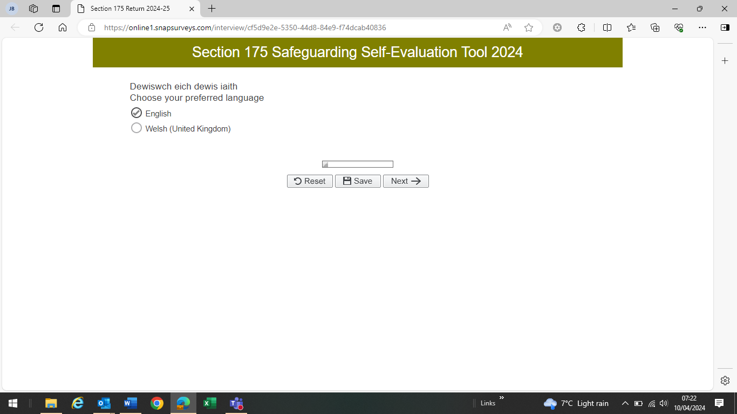

Followed by:

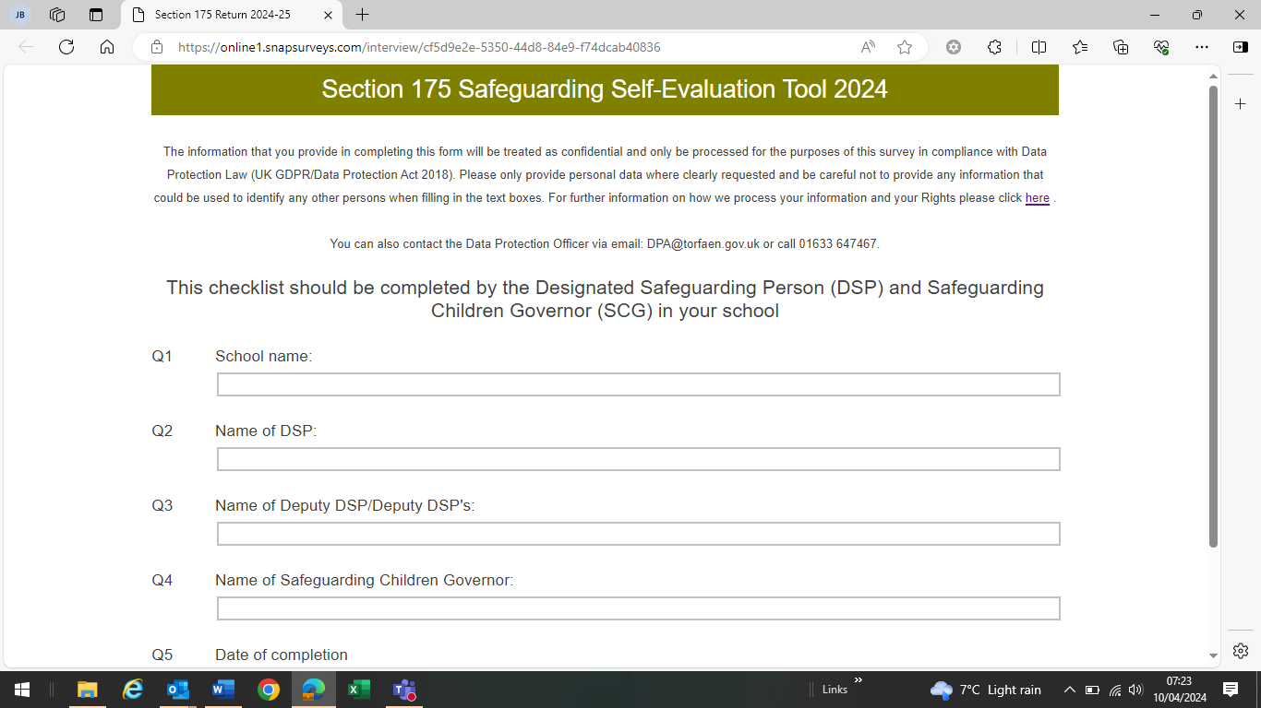
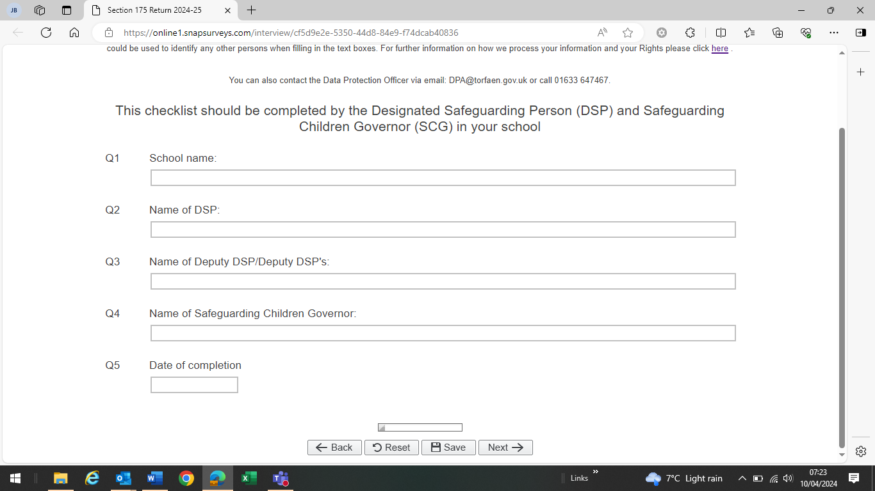

Each question on the evaluation requires a response and the user cannot progress to the next page unless all questions are completed (the evaluation will highlight any questions in red that have not been answered or that require further narrative).

Prompt boxes asking for more information will appear for responses to certain questions.

At the foot of each page there is a progress report bar along with a Back / Reset / Save and Next option. Use the Save function to save all answers and you will see following message confirming responses have been saved:

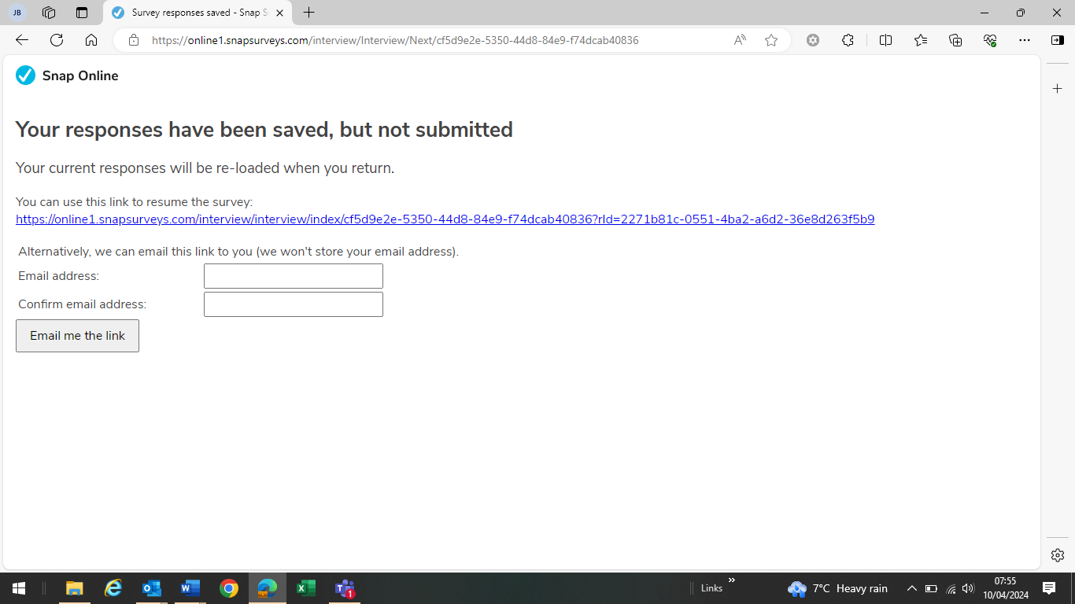

To resume survey either click on the link shown or to return at a later time enter email address and an e-mail link will be sent to you accompanied with the following message:

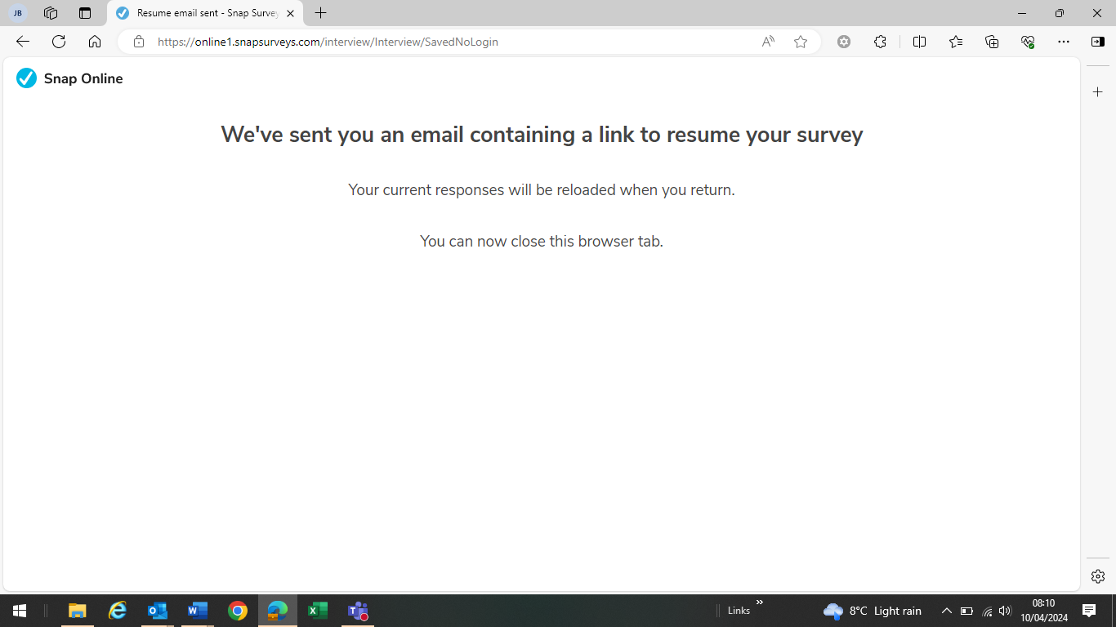

An email will then arrive containing link to resume survey when you are ready to continue:

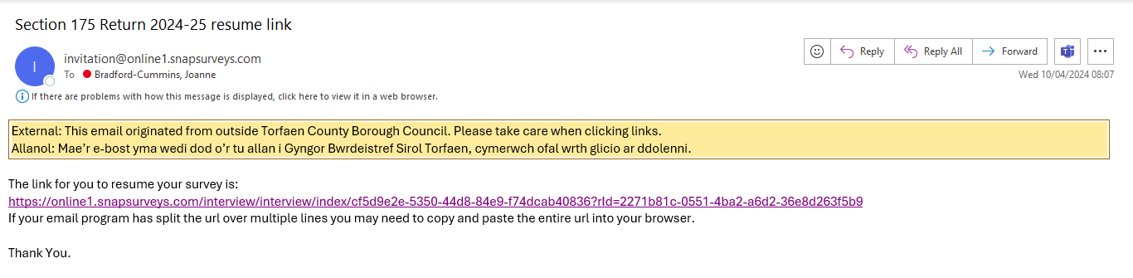

It is important to save regularly as you will be taken to the last page you saved prior to exiting.

Below is a snapshot of the last section on the evaluation:

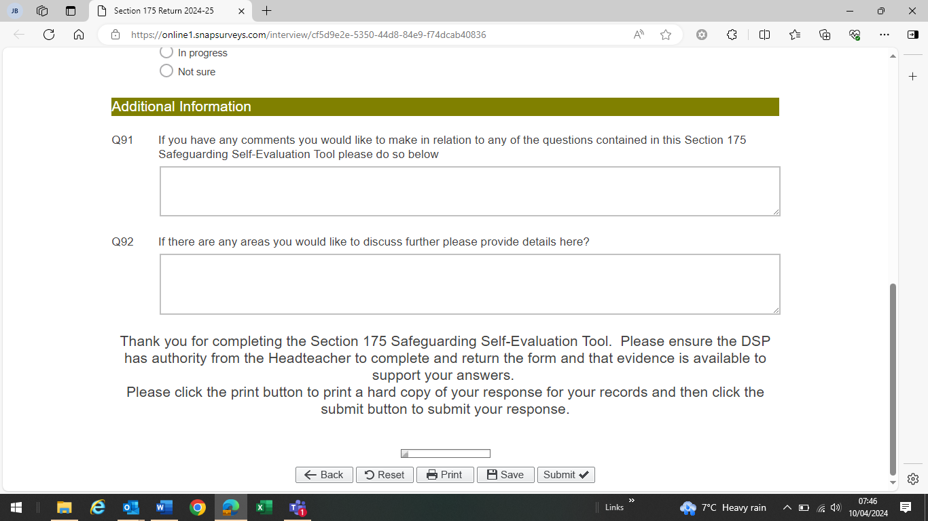

Once all questions have been completed please ensure you follow the instructions in the order shown:

- Click the Print button to print a hard copy of the Section 175 Safeguarding Self Evaluation Tool for your records.
Note: this is your only opportunity to do this as once the evaluation has been submitted you will be unable to access your completed evaluation electronically.

- Then click Submit to forward your response

PLEASE NOTE: when completing the Section 175 Safeguarding Self Evaluation Tool the same PC needs to be used, accessing the evaluation on a different machine will result in all previous answers being lost.

_________________________________________________________________________

Timeline for 2024 (this will change annually as necessary):

- The Section 175 Safeguarding Self Evaluation Tool will be sent to schools annually in the summer term.

- The evaluation is to be completed by the DSP in liaison with the SCG.

- The governing body should be made aware that the school is completing the evaluation.

- Schools to complete returns by Wednesday 22nd May 2024.

- Local Authority to analyse evaluations June/July.

- Individual responses to be sent to each school beginning of September.

- Summary of responses to be included in the annual safeguarding report.

- Feedback from the process should be reported to the governing body and any recommended actions agreed and subsequent timescales (usually within one month).

- Completion of actions to be reported back to the governing body within the agreed timescales.

- Confirmation of completion of actions to be reported to Local Authority by the end of the Autumn Term.

- All comments to be forwarded to Jacquiline.watkins@torfaen.gov.uk or Joanne.bradford-cummins@torfaen.gov.uk to inform future development/improvement.

Appendix 4

School Report to Child Protection Conference
School Name –
Date of Conference -
Name
Date of Birth (day/month/year)
Address
Special Needs Register/IEP/Other
Known Medical Conditions
Attendance Record
Punctuality
Any known significant events (Child or Family History)
Child’s Needs and Development

Academic ability and/or performance.

Appearance and presentation.

Stage of development

School Report to Child Protection Conference
Name
Social and Emotional Wellbeing

Peer Group

Behaviour
Personality

Interaction with Teachers

Emotional Well-being
Family and Parenting/Carer Environment

Level of parental/carer Involvement

Knowledge of wider family circumstances
Social circumstances.

Level of participation in after school clubs (for e.g.)
Relationship between teachers and parents/carers

Attendance at parents evening

School Report to Child Protection Conference
Any other comments

Appendix 5
Safeguarding Incident Log

In order to ensure that appropriate information is available regarding any child protection concerns that have been raised it is necessary to complete a child protection log which briefly records all concerns, communication and actions taken.

The log must include:

- Date/time of receipt of information.

- Details of who the information was received from and given to.

- Date/time/location of incident.

- Name/DOB/address of child.

- Details of what happened/observed to happen.

- It is imperative that the child’s own words are recorded.

- Details of anyone else involved.

- What action was taken at the time?

- Details of action taken by DSP

- Date and time of recording of log.

- Log signed and dated.

- Details of referral e.g. to who, when.

- If no referral – why – log kept on record.

- Details of LA officer informed.

- Record of suggested action by social care, LA, police e.g. advice re child being sent home or remaining in school.

These records should be maintained in school securely.

Appendix 6

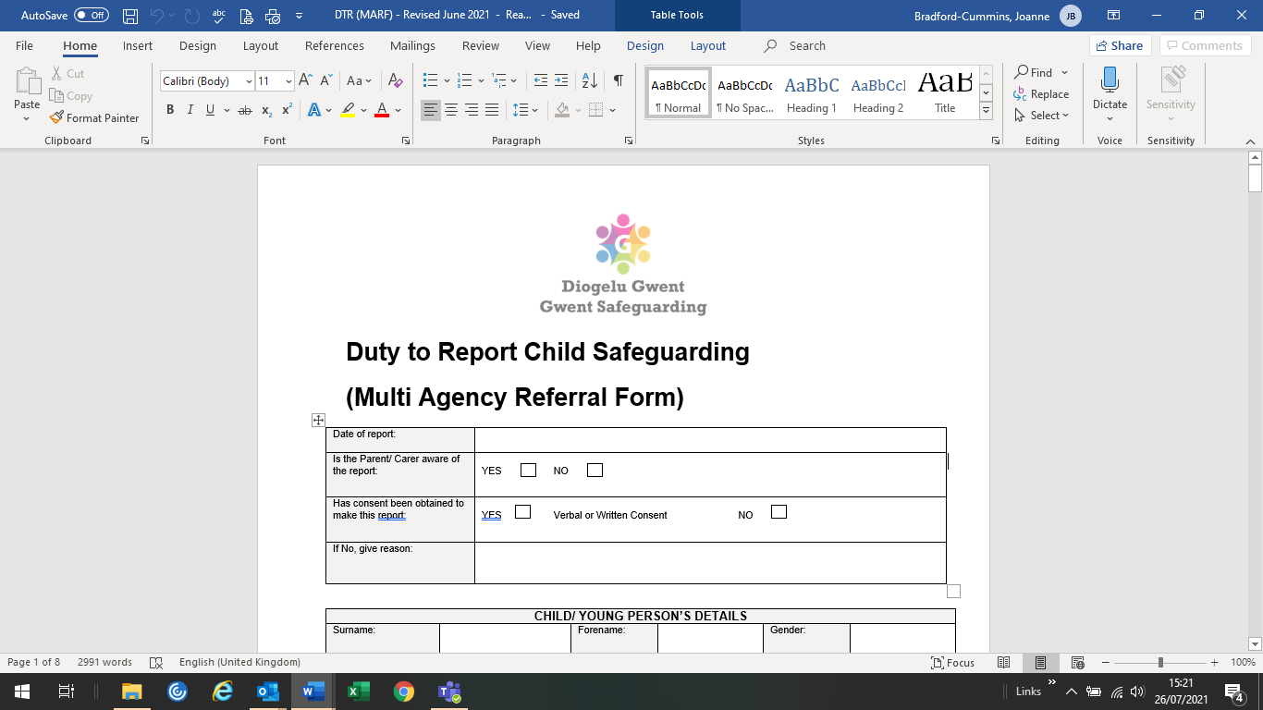
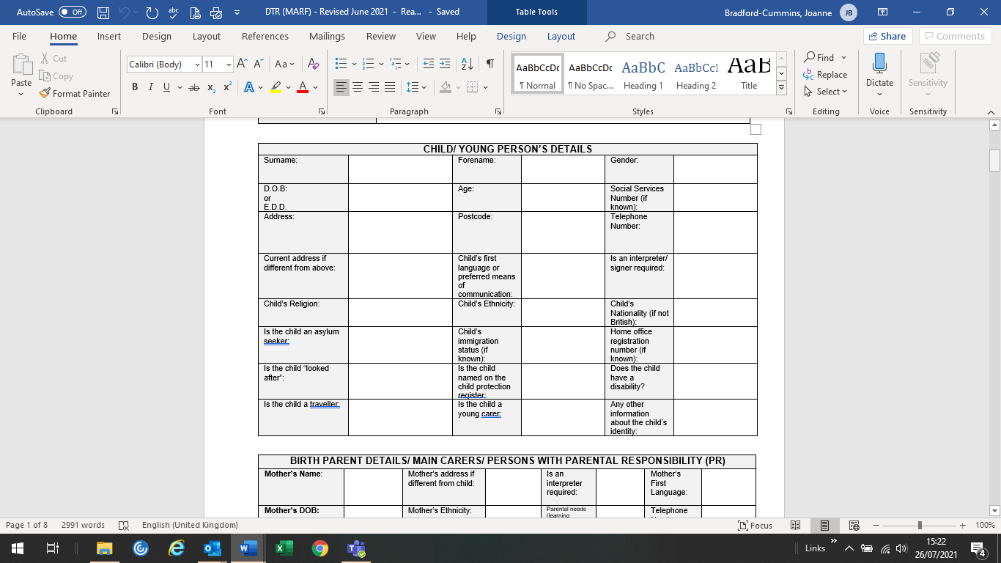
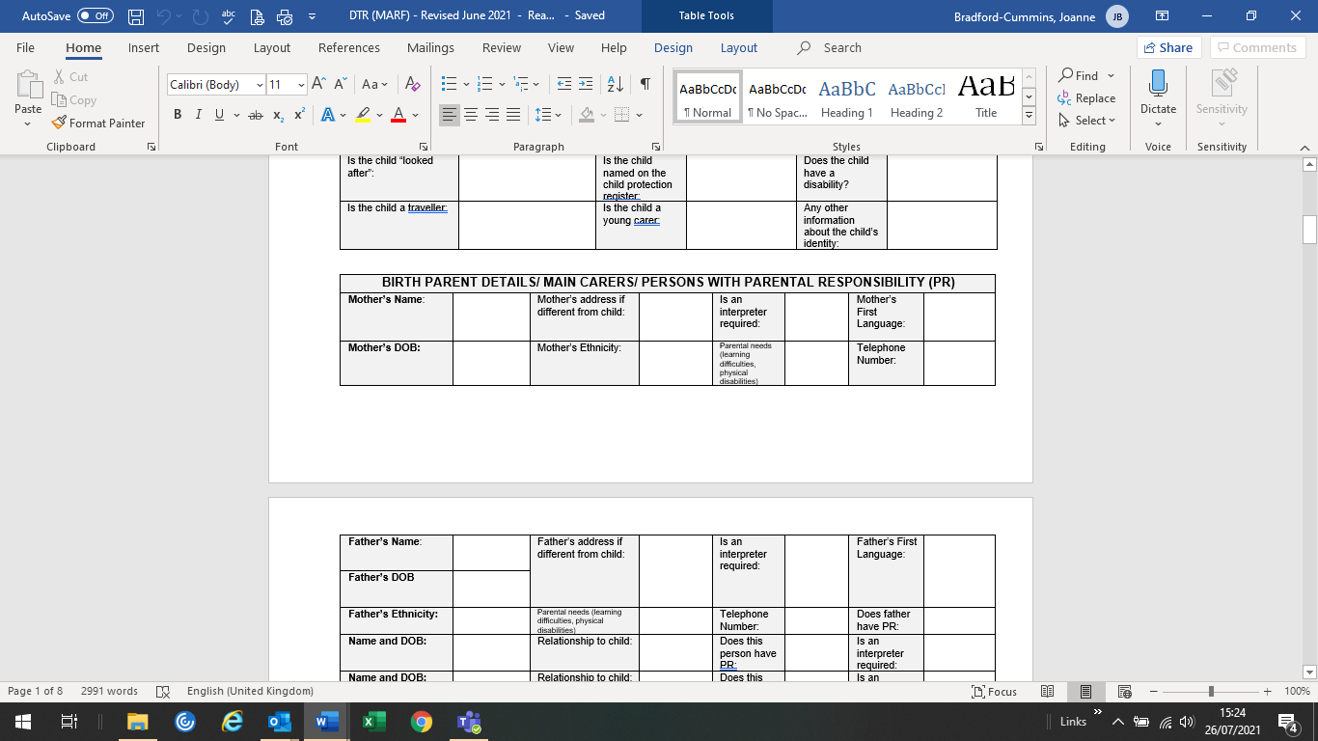

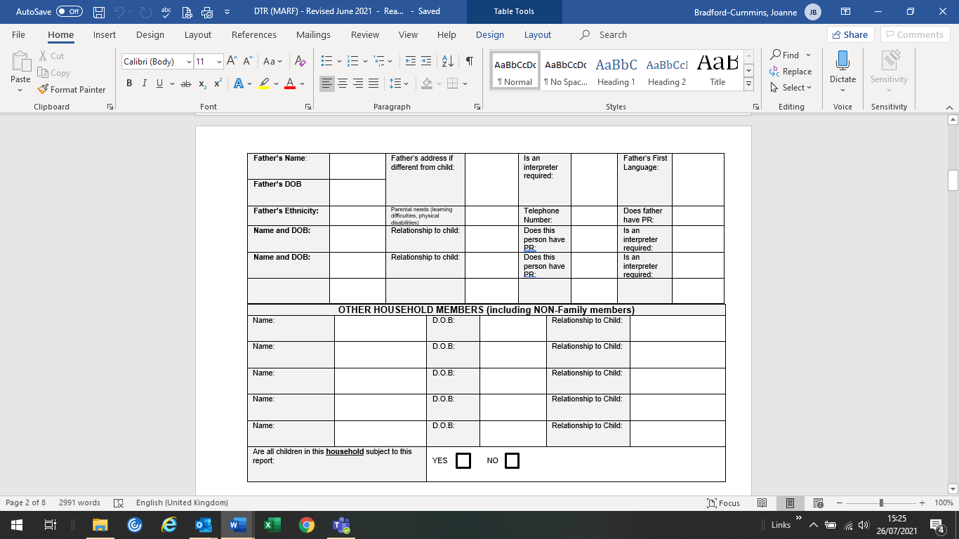
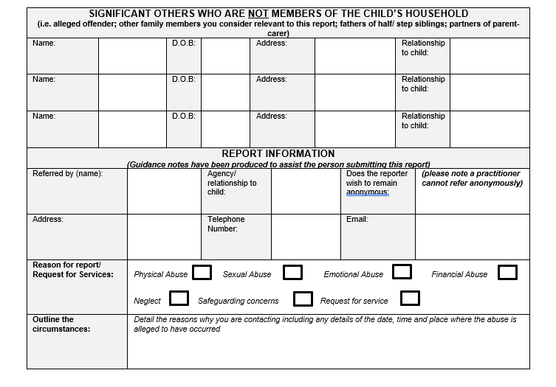
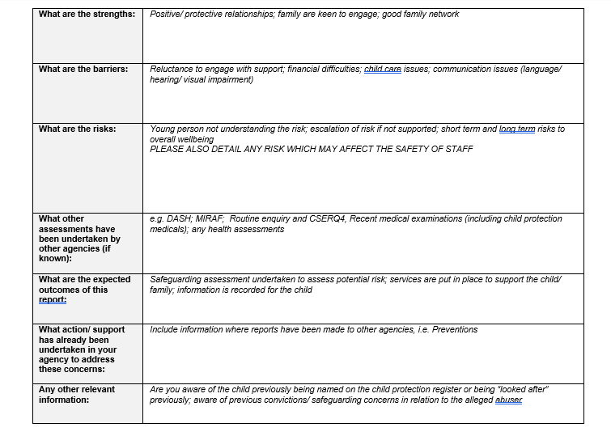
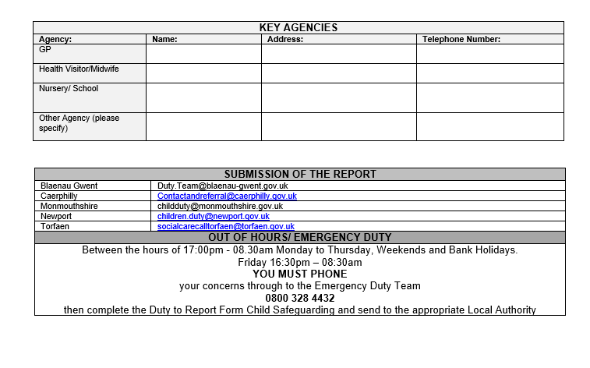

Appendix 7

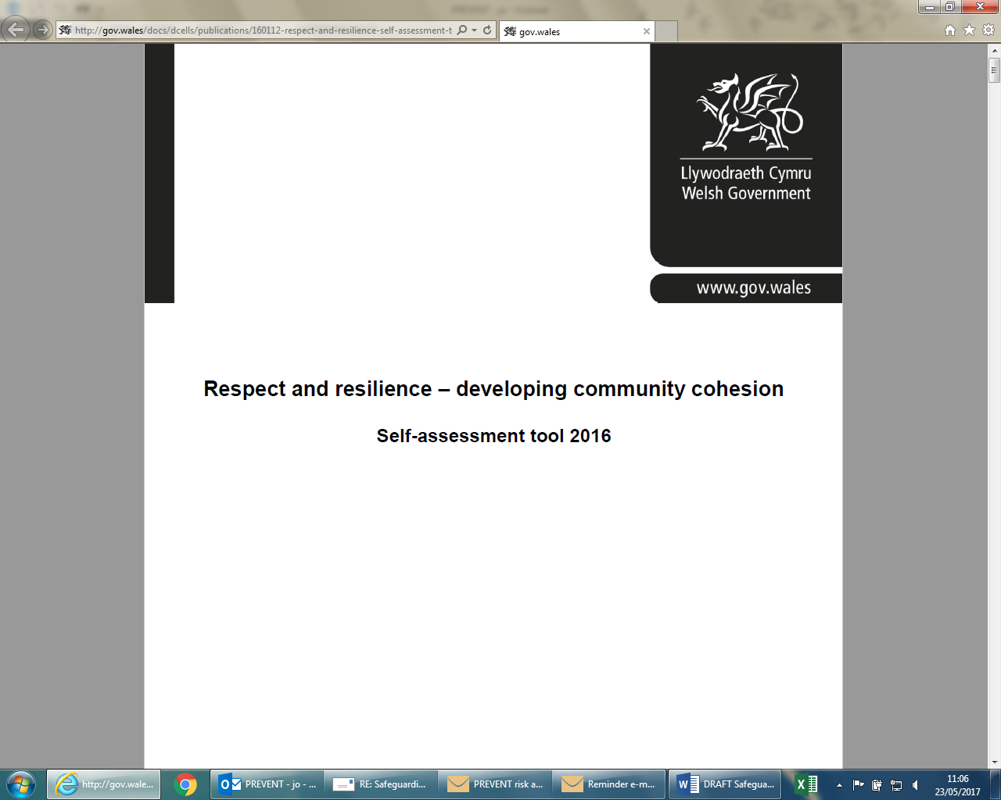

This self assessment tool has been adjusted to align it with the new Counter-Terrorism and Security Act 2015, Estyn’s Common Inspection Framework and the duties and responsibilities that schools are required to meet. This includes actions to address guest speakers, events in schools, risk assessment and safeguarding all learners within schools and other settings.

Please copy link below into your web browser to view self-assessment tool:

http://gov.wales/docs/dcells/publications/160112-respect-and-resilience-self-assessment-tool-en.pdf

The purpose of this tool, which should be used with the updated Respect and resilience – developing community cohesion guidance http://gov.wales/docs/dcells/publications/160111-respect-and-resilience-update-en.pdf (copy link into web browser to view) is to enable schools in Wales to assess their levels of compliance with both the Counter-Terrorism and Security Act 2015 and best practice in the maintenance of a safe learning community.
Schools can use this as a checklist of their readiness and their overall compliance. It allows for opportunities to prepare and implement plans in response to gaps in performance and in any neglected areas of responsibilities. It is important that schools and their governing bodies prioritise their safeguarding plans to comply with the essential parts of the Act to maintain a safe learning community.

Appendix 8

Transfer of Child Protection Records within Educational Establishment
Receipts

(Please print all information)

Name of Child: ____________________________________________________

Date of Birth: ________________________________________

UPN number: ________________________________________

Admission Date: _______________________ Leaving Date: _________________________

Name of Current School:

Address of Current School:

Name of DSP:

---------------------------------------------------------------------------------------------------------------------------

Date file exchanged by hand: _____________________________________________ or

Date file posted by recorded delivery: ___________________________________________

Signature of current DSP: ________________________________ Date: _______________

Name of receiving school: ____________________________________________________

Address of receiving school: __________________________________________________

_________________________________________________________________________

Name of Receiving DSP: ____________________________________

Date file received by Hand: ________________________________________________ or

Date received by recorded delivery: _________________________________

Signature of receiving Designated Safeguarding Person:

________________________________________ Date: __________________

Please ensure this completed form is returned to the originating school without delay.
The originating school should keep this receipt securely.

