Gwaith Cartref – Blwyddyn 1 - Year 1 Summer Term

This is your homework for the whole term. Choose 8 activities that you would like to do. You can take a picture of what you have done and share it on Seesaw or complete it on paper. Bring it in half termly. Remember you should also read your book from school and books at home with an adult.
Create a bug hotel to help the minibeasts  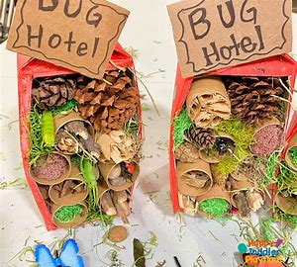  How to make a bug hotel - EYFS - Reception - BBC Bitesize | - Practise your time telling skills… (to the hour -o’clock to start)  Telling the Time - Mathsframe  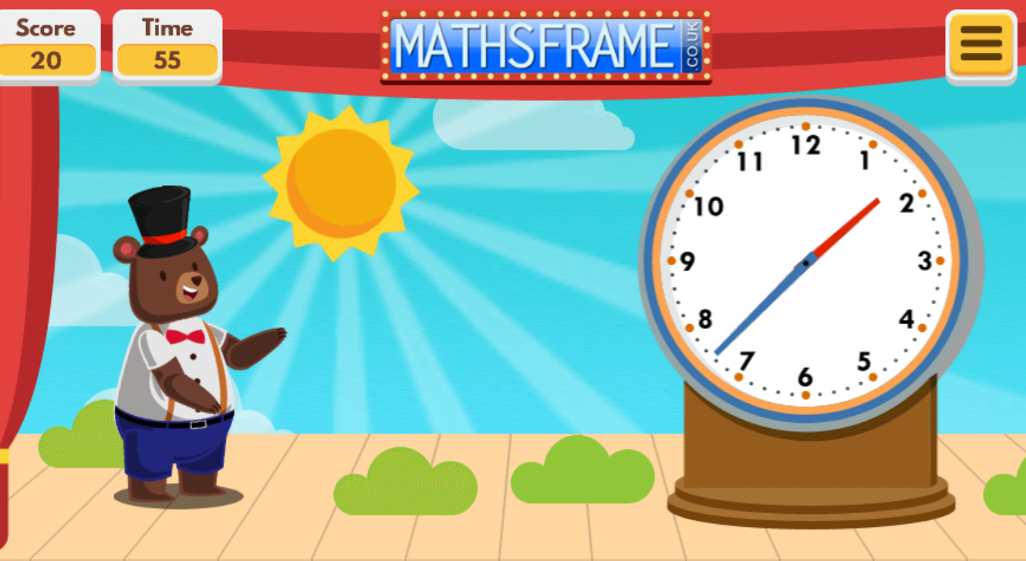  Play with a family member and send a photo of you playing the game.  - Practise writing your numbers to 10/20/50  - Practise your maths skills using Mathseeds
Practise reading …  What The Ladybird Heard    Retell the story using actions (first, next, after that, finally). Send a video of you retelling it. | Read one of your books to your parents.  Describe:  The title; the author; the illustrator; is it fiction/non-fiction? What is it about? Read the blurb together.  Retell the story to your parents.
Draw/paint a picture of a Spring/  Summer Day  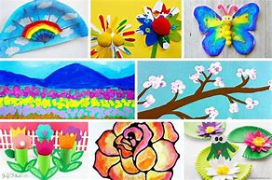 | Build a model of an animal and find out about the animal to talk about with your class.  Make your model using junk/ furniture/ natural materials/ lego…….
Practise your tricky words  song  Little Bird Spelling || Practise spelling Common Exception Words (ictgames.com) | Make a camping themed recipe  Make or cook a recipe with a family member and send a photo of you cooking/ eating your recipe.  20 Easy and Fun Campfire Recipes Kids Will Love | Dotting the Map
Practise your Welsh about--- animals    Learn Farm animals in Welsh for primary with Four in a row game (learn-welsh.net) | Choose an activity that you like to do and write about it/create a picture of it to show to the class.  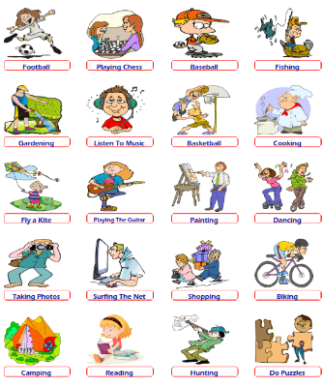
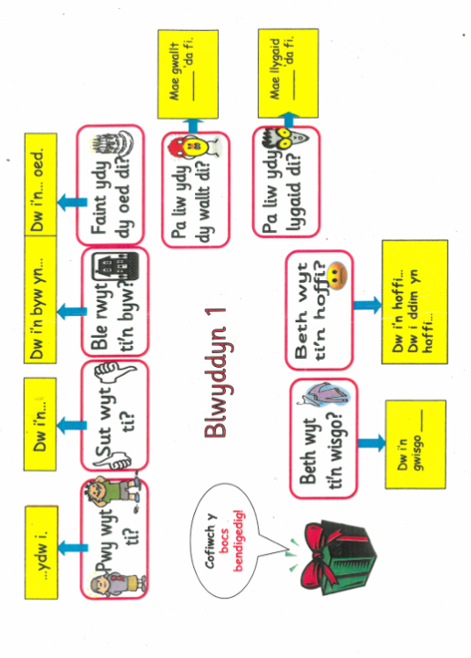
This is our new Welsh placemat.
We will be working on these phrases all term. The children can also practise at home with you.

