Gwaith Cartref – Blwyddyn 1 - Year 1

This is your homework for the whole term. Choose 8 activities that you would like to do. You can take a picture of what you have done and share it on Seesaw or complete it on paper. Bring it in half termly. Remember you should also read your book from school and books at home with someone.
Make a bird feeder for the birds in your garden.  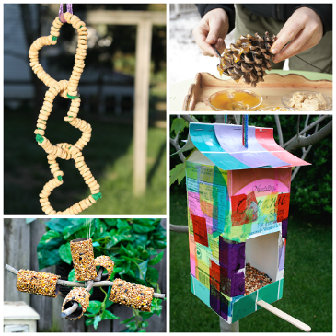 | Practise your Maths skills…  Helicopter Rescue - Mental Maths for 4 to 8 Year Olds (topmarks.co.uk)    Play with a family member and send a photo of you playing the game.  Practise your maths skills on Mathseeds (practise each week)
Practise reading …  Follow the story about Pip, the Blackbird:    Who are the characters? What was your favourite part of the story? What was your least favourite part? Why? What was Pip’s special talent? Can you find “Pip”; “what”, “do” and “we” on the pages? | Look for signs of Winter and then Spring….  Go for a walk and find five things that show you that it’s Winter. Then send a photo to us or draw pictures of them.  
Draw/paint a picture of your favourite film/show.  Use pencils/crayons/paint to create a picture of your favourite story- the characters, setting and favourite part. Talk about your favourite part of. Write words/ sentences about the story. e.g. I like…. My favourite part is…. The characters are….. | Build a puppet show/theatre at home! Collect materials and items in your house and design and build a puppet show/theatre. Add cushions and enjoy a “show”!  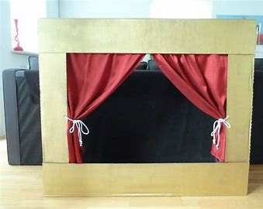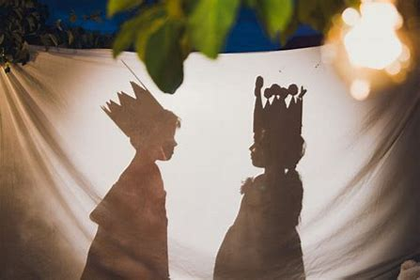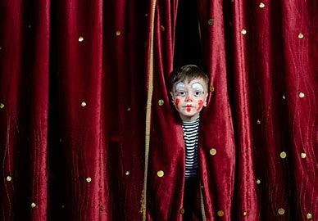
Practise your tricky words  song  Little Bird Spelling || Practise spelling Common Exception Words (ictgames.com) | Make a Spring or Easter themed recipe  Make or cook a recipe with a family member and send a photo of you cooking.  Top Ten Spring Baking Ideas for Kids - Twinkl
Practise your Welsh….about what you like (Dw i’n hoffi…)   Beth wyt ti hoffi wneud? - Find the match | Practise your Maths skills…  Up to 20 (daily) Adding and Subtracting to 100 

