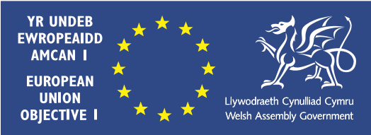

Torfaen County Borough Council Education Service, Shared Ambitions
Our vision for education is:
Our vision is
Torfaen as a Council cares passionately about the future of our children and young people and are committed to supporting them through a relentless focus on raising standards of achievement, health and wellbeing for all in a safe, respectful, inclusive and caring environment

To support and challenge all education settings through strong partnerships, to provide high quality learning experiences to enable all learners to be the best they can be

To inspire all children and young people, irrespective of ability, to learn throughout their lives and broaden their experiences; develop their language, knowledge and skills including technology to enable them to become confident, ambitious citizens able to take a full part in life in the borough, Wales and the world

The impact of the pandemic:
The COVID-19 pandemic has had a significant impact on the lives of everyone. For the children and young people of Torfaen, the disruption to learning as a consequence of the initial lockdown, the move to blended learning and the continual to and fro of self-isolation and subsequent lockdowns have all taken their toll on their mental health and progress in learning. For older learners taking public examinations, it has meant significant additional anxiety as examinations were cancelled and progression routes onto further and higher education, and employment called into doubt.
As a Local Authority, Torfaen fully understands all these additional issues. We have worked in close collaboration with Council Members, schools and learners across the borough to put in place measures in an attempt to address the gaps in learners’ knowledge and understanding and enhance our support to address mental health issues for our children and young learners.
Consequently, in addition to our core vision for education, Torfaen have added two further priorities in the short and medium term to specifically address these issues and mitigate against the negative impact on the wellbeing and future life chances of all children and young people in the borough.

To work tirelessly in collaboration with schools, external providers and Welsh Government to address the identified skills and knowledge gaps of learners through the provision of recovery programmes and additional learning resources.

As a Council service embrace and embed beneficial new ways of working arising from the pandemic to enhance the quality and impact of the service’s support to schools and provision within schools.

Strategic context:

Underpinning the Corporate Plan are a wide range of supporting plans that set out in detail the specific support and improvement activity undertaken by our schools, the Education Service and the Education Achievement Service (EAS)

Torfaen County Borough Council Corporate Plan 2016-21 is the over-arching vision of the Council, which lays out its clear priorities over a five-year period. The third priority within the plan (CP3) is “raising educational attainment”. The Corporate Plan also includes Wellbeing Objectives, including ‘provide children & young people with the best start in life’.
Strong partnership working
To achieve our agreed vision, the Council and Education Service is working relentlessly to embed a strong culture of collaboration across all Council services, external providers, schools and their communities including both learners and parents/carers.
At the core of this collaboration is an understanding and acceptance that all Council services and commissioned providers must deliver highly effective support to our schools. Monitoring will enable Officers and Members to understand how well our schools are performing and allow for informed early intervention and appropriate support. Monitoring will be set against four agreed areas of focus:
- Vision & Leadership
- Curriculum
- Learning and teaching
- Wellbeing



The Service as a Learning Organisation

Our work in collaboration with Bangor University has seen the Education Service implement beneficial changes aligned to the OECD’s principles around successful learning organisations. It also mirrors the best practice in many of Torfaen’s highly effective schools.

The strategic intent of this development is to:
Enhance the Service’s capacity to support its schools to deliver the key changes to education provision in Torfaen as outlined in the Donaldson Report and the Curriculum Reform Wales document.
Develop systems and practice across the Service that enhance the productivity and effectiveness of its staff to successfully support schools in securing the necessary progress against the conditions found in good schools.
Establish a common understanding and practice aligned to our stakeholders that accelerates the progress made by Torfaen schools, particularly in the secondary sector.

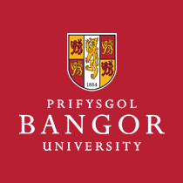

We would like to acknowledge the following stakeholders for their valued contributions towards the collaborative development of this vision:
Members of the Council’s Children and Young People Oversight & Scrutiny committee
Members of the Torfaen Headteachers Strategic Group
Torfaen Young People’s Forum
Council Service Managers
The members of St Alban’s RC High School student council
The members of Ponthir Church in Wales Primary School student council
Crownbridge Special School pupils

