Gwaith Cartref – Dosbarth Derbyn - Reception

There are 10 activities to choose from for homework bingo. You only have to choose 1 to do but you can do as many as want! You can take a picture of what you have done and share it on Seesaw or complete it on paper/create a model and bring it in to show and tell. Remember you can also read your book from school and practice your monster phonics!
I spy something beginning with…  Play ‘I spy’ around the house to practice linking objects to sounds we hear! ‘S is for stairs’. Draw a list of everything you find.  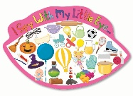 | Number hunt…  Numbers are everywhere! Go for a walk and see what numbers you can find. Send us photos on SeeSaw!    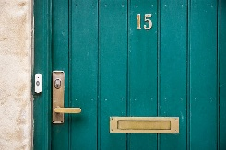  
Create…  Create a model/drawing/painting of your favourite nocturnal animal! Bring it in to show us!  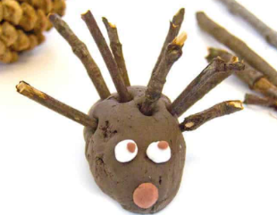  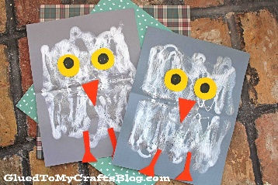 | Signs of Autumn hunt….  What can you see that tells us it’s Autumn? Send photos of the signs of Autumn on SeeSaw.  
Build …  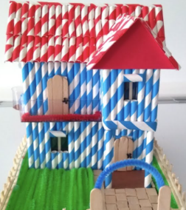  Build one of the houses from The Three Little Pigs!  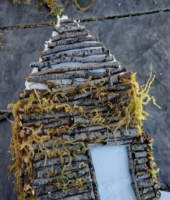  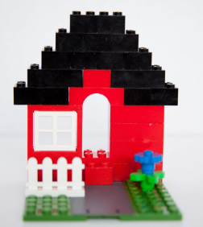 | Be active…  Do you attend any clubs or simply enjoy going for a bike ride? Share your active adventures with us.    
Investigate…  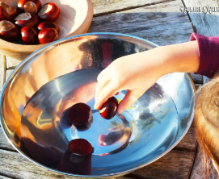  Floating and sinking! Collect some Autumn items and/or toys and test to see if they will float or sink in water. Let us know what you find out!   | In the Beginning…  Please seethe R.E newsletter for suggested home learning for the topics we will be covering this term.  
Pori Drwy Stori…  Watch this space!  An Autumn pack will be arriving soon!   | Learning with ICT….  Maths Seeds! Logins will be given next week.  

